Howard Zhang @ Savills, HK

hzhang@savills.com.hk

Abstract

This guide covers the complete C3 platform setup, from which country specific customizations can then be overlaid on top.

commercialcube (c3) installation guide

Adapted from Savills Australia’s Architecture

Table of Contents

1 Setup Base Dynamics CRM 3

1.1 Install Base Version Dynamics CRM 2016 3

1.2 Install Base Version SSRS Connector 10

1.3 Upgrade Dynamics CRM 2016 13

1.4 Upgrade Dynamics SSRS Connector 15

1.5 Configure Claims Based Authentication 17

1.6 Configure Internet Facing Deployment 21

2 Deploy CommercialCube Customizations 25

2.1 Import Custom Solutions 25

2.2 Import Configuration Data 27

2.3 Import Queues Data 29

2.4 Import Teams Data 35

2.5 Activate Processes for Custom Solutions 40

3 Setup SharePoint Integration 45

3.1 Create Site Collections 45

3.2 Setup Automatic Permission Granting for Dynamics CRM User Accounts 49

3.3 Configure Document Site Collection 50

3.4 Configure Web Application and CRM Document Management Settings 52

3.5 Configure Image Site Collection 56

3.6 Add Permissive X-FRAME-OPTIONS Header Feature 60

4 Setup Image Portal 64

5 Update CRM Configuration Settings 67

5.1 CRM Organization ID Setting 67

5.2 Image Portal URL Setting 68

5.3 Report Server Settings 68

5.4 SharePoint Settings 69

5.5 Admin User Setting 69

6 Configure Dynamics CRM for Using FetchXML Reports 70

6.1 Set Service Principal Names for Service Account 70

6.2 Edit Configuration for Dynamics CRM Website 71

6.3 Verify FetchXML Reports Can be Run 72

7 Verifying Integration 77

7.1 Verify CRM component to database component integration 77

7.2 Verify CRM component and SharePoint component integration 77

7.3 Verify CRM component to image portal component integration 79

7.4 Verify CRM component to reporting component integration 80

8 Appendix: Add Organization 83

9 Appendix: Add New User 86

# Setup Base Dynamics CRM

This section covers the installation, upgrade and authentication setup of Dynamics CRM and its related SRS connector. This section is to be skipped when adding an organization for a country, and instead, the “appendix: add organization” can be referred to for this purpose.

Note that the following sections or sub-sections require the addition of DNS entries, which due to privilege limits, have to be performed by those who are able to perform this, such as the infrastructure team:

* Configure claims based authentication
* Configure internet facing deployment
* Create site collections
* Setup image portal

The steps where this is involved are marked with an external interaction symbol . It is advisable to collect all these DNS entries together and request for their addition by the external team under a single inquiry. Like



## Install Base Version Dynamics CRM 2016

1. Mount the disc image file “SW_DVD5_Dyn_CRM_Svr_2016_English_MLF_X20-55895.iso” if this has not already been done.  
    The ISO file has to be provided onto a shared drive by the infrastructure team initially.
2. Once mounted, browse to the mounted drive and run the “SetupServer.exe” installer.

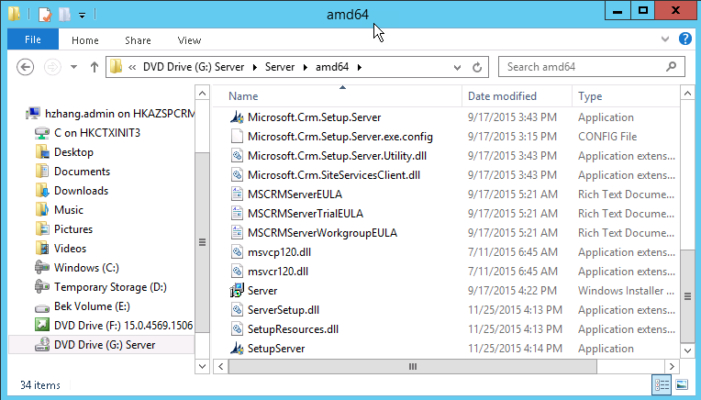

1. Accept the default installation directory.

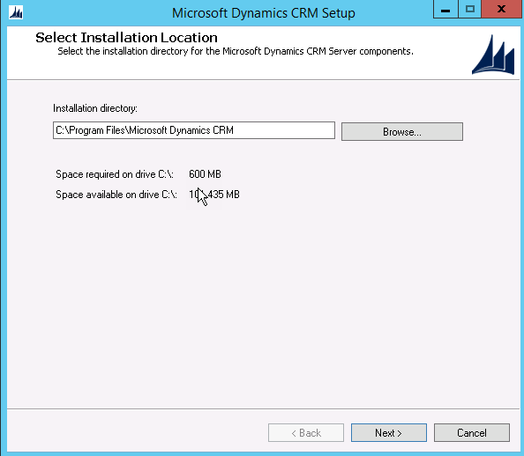

1. If there are any missing required components, go ahead and select “install” for them.

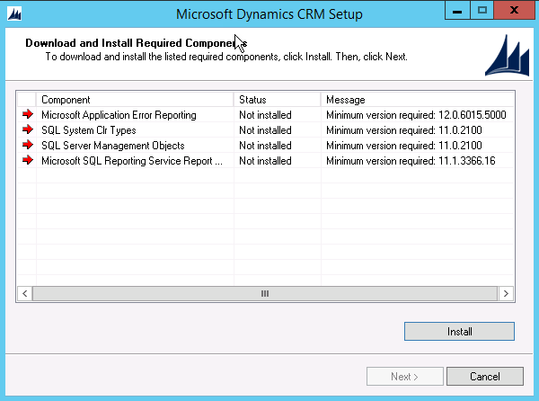   
  
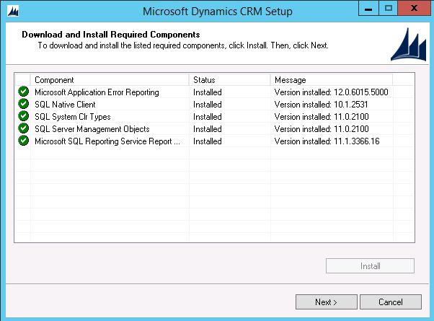

1. Next, elect to get recommended updates. Note that it is possible for there to be no updates available even if this option is chosen.

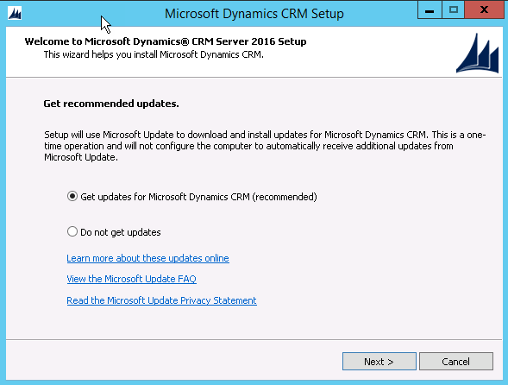

1. For specifying server roles, accept the default of “Full Server” role, so that all items are selected.

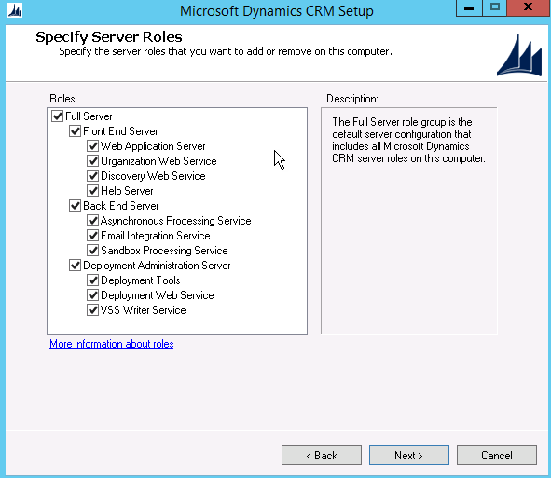

1. Then, elect to “create a new deployment.” Provide the name of the SQL Server designated for the Dynamics CRM data tier and that has already set up for this CRM installation. For this example, it is “HKAZSQL1\HKAZSQL1”. Click through any subsequent warning dialogs.

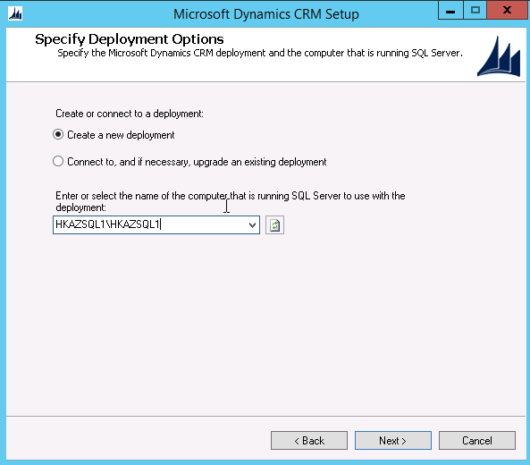   
  
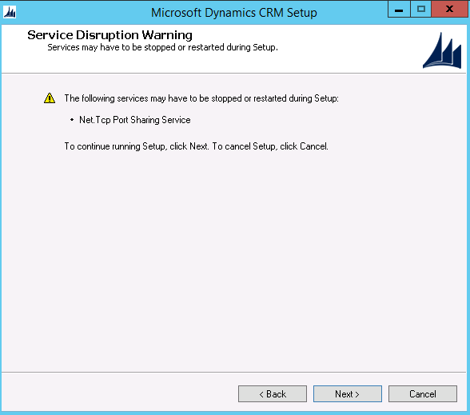

1. For the organizational unit selection, browse and select the designated organization unit from Active Directory that was previously set up for this CRM installation. For this example, it is named “Production C3 Groups.”  
    The Active Directory (AD) organization unit (OU) would have been created by team members who have AD privileges, such as those from the infrastruture team.

The user from which you are installing CRM should have below mentioned permission in Active Directory.

fpdsavills.com.hk/Groups/Application Members Group/GatewayCRM Groups

And local admin permission required in sqlserver.

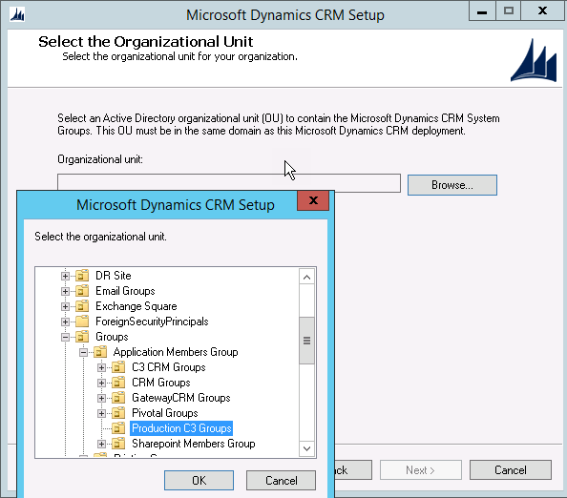   
  
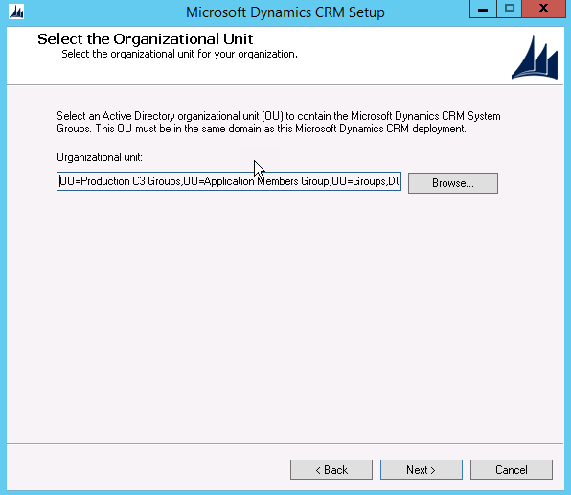

1. Use the “FPDHK\GatewayService” domain account when specifying the service accounts for all of the Dynamics CRM services. The password must be entered for each service as well.

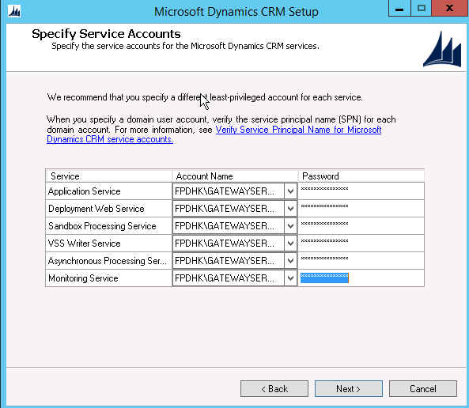

1. Choose to create a new website. For this example, the port number of “80” is used. This is sufficient for now. The port can be changed later on.

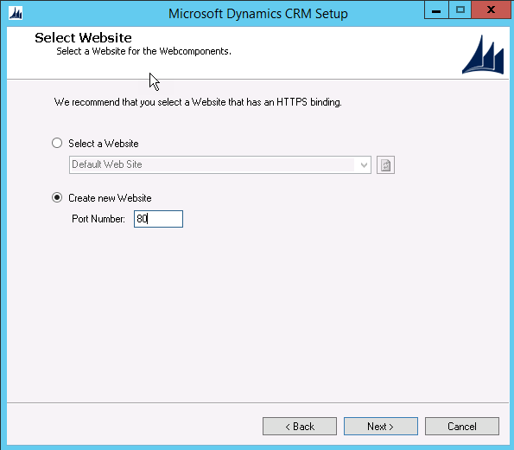

1. The “specify email router settings” page can be skipped by choosing “next.”
2. Then on the “specify the organization name” page, fill in the “display name” entry using a meaningful name that indicates both the country being targeted and the delivery phase. In this example, the display name value is “IN_C3PROD”, which uses “IN” as a prefix to indicate India, and a postfix of “PROD” to indicate development environment.
3. The “unique database name” is automatically filled in. This provided value is generally acceptable.
4. With the “browse” command under the “ISO currency code” setting, select the appropriate currency for the new organization being created. In this example, the currency chosen is INR, which is the Indian Rupee. The remaining values are filled in with their corresponding defaults.
5. Leave the rest of the values as-is, and continue by selecting “next.”
6. Provide the report server’s URL. For this example, the URL is “http://hkazsql1:2014/ReportServer”.  
    The name of the report server is provided by those that have initially set it up, such as the infrastructure team.

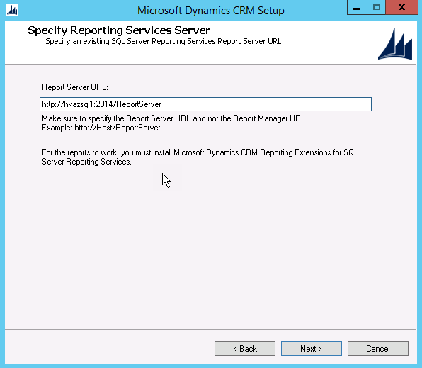

1. For Microsoft update preference, the “I don’t want to use Microsoft Update” option can be selected.

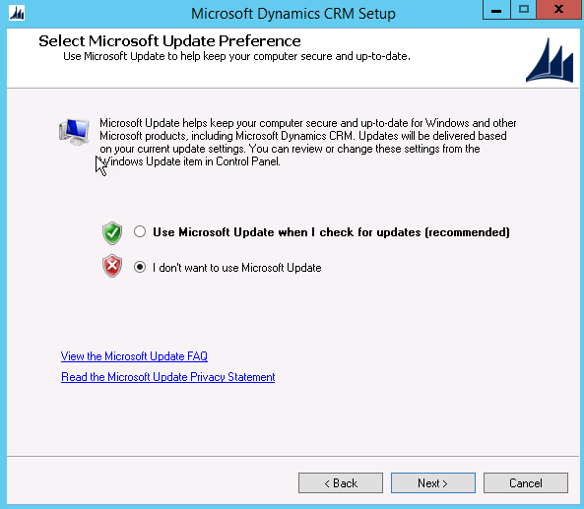

1. Some of the actions that can be taken if the “system checks” step is not passing:

* For the “Microsoft Dynamics CRM Server User Input” section within “System Checks” to pass, the service account previously specified must be have “Performance Counter” permissions.
* For the “Microsoft SQL Server” section to pass during “System Checks,” the installation user account must have “sysadmin” level permission on the SQL Server instance specified for this CRM installation.
* If warnings relating to service principal names are shown for the “Active Directory” section during “System Checks,” then this would indicate that service principal names are not able to be set for the specified Dynamics CRM services during installation. In these cases, the service principle names need to be manually set after the this part of the installation is completed. For example, to perform this set up for the MSCRMAsyncService, run the following commands in PowerShell:  
  setspn -s MSCRMAsyncService/HKUATCRM FPDHK\GATEWAYSERVICE  
  setspn -s MSCRMAsyncService/HKUATCRM.fpdsavills.com.hk FPDHK\GATEWAYSERVICE

Other services may require the same corrective steps if warnings are shown for them.

1. Once “System Checks” are passed, installation takes place and when it is finished the completion dialog is shown. Choose “finish” to restart the server to finish the process.

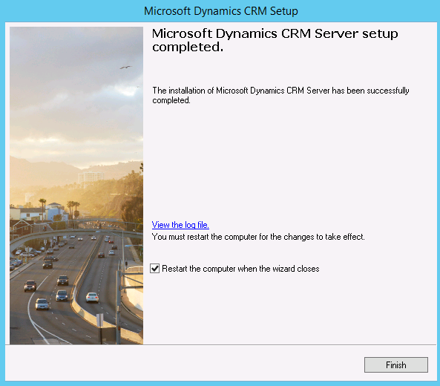

1. After the server restart, navigate to the Dynamics CRM by using either the IP or computer name of the CRM server. Use the HTTP protocol.
2. The main landing page of Dynamics CRM should be shown normally without errors.

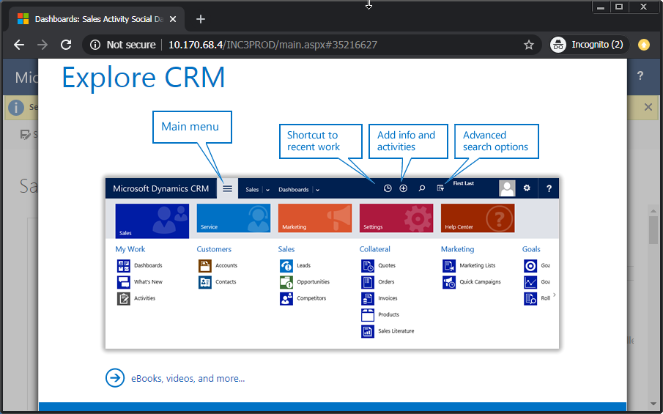

1.  Open the “about” dialog to ensure that the version at this point is “8.0.0.1088.”

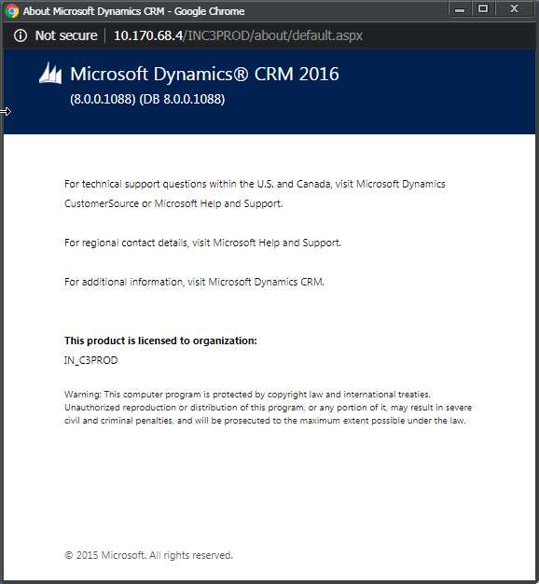

## Install Base Version SSRS Connector

To install the SRS Data Connector, follow these steps:

1. Sign in to the data server tier with an account that has “sysadmin” privileges for the SQL Server instance. Mount the Dynamics CRM installation ISO if it has not already been mounted. Open the mounted drive in File Explorer. Navigate to the “\Server\amd64\SrsDataConnector” folder.  
   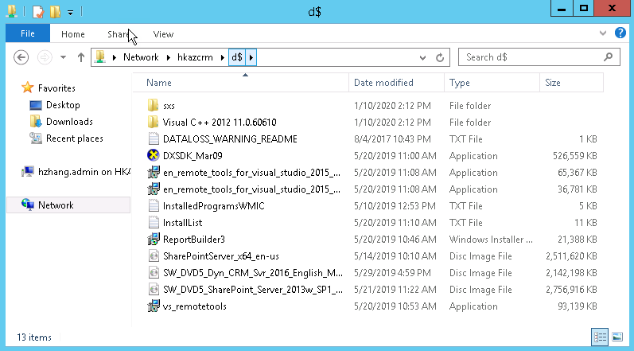
2. From here, run the “SetupSrsDataConnector” installer.  
   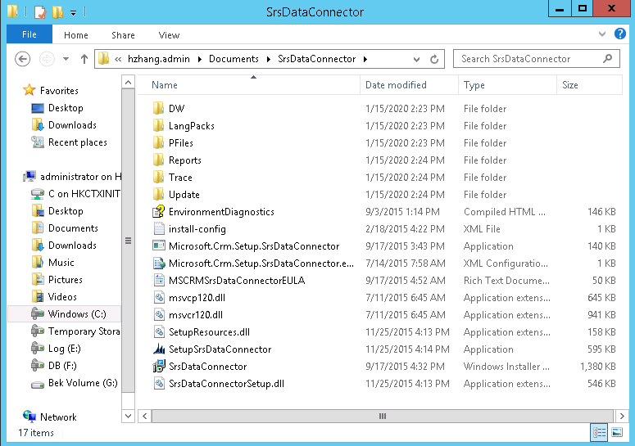
3. Elect to “get updates for Microsoft Dynamics CRM.”  
   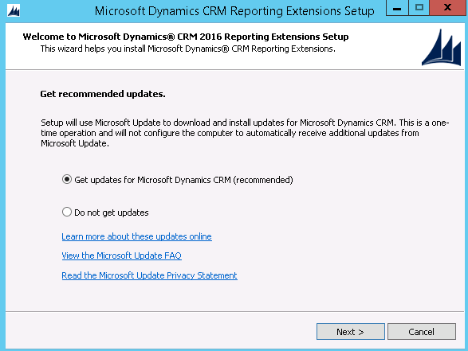
4. Next, specify the SQL Server instance. For this example, it is “HKAZSQL1\HKAZSQL1”.   
   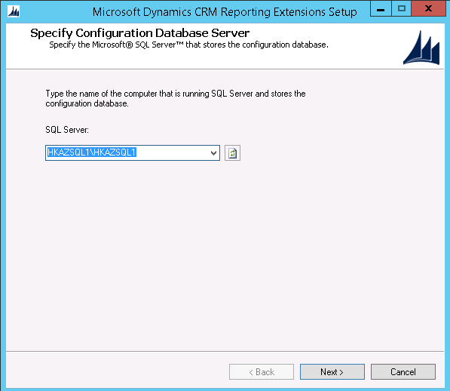
5. Next, specify the SSRS instance. This is selected from a drop-down list, and the there should only be a single choice, which happens to be the same instance as the Dynamics CRM instance.  
   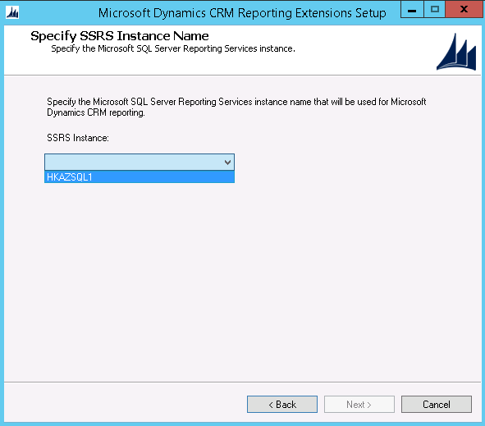
6. After this, elect to not use updates by selecting “I don’t want to use Microsoft Update.”  
   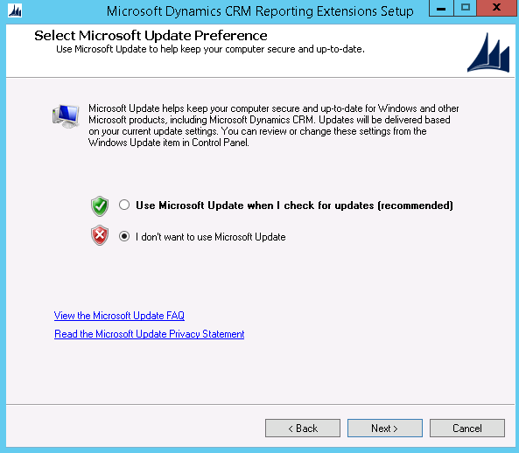
7. Follow the installation wizard to the end.

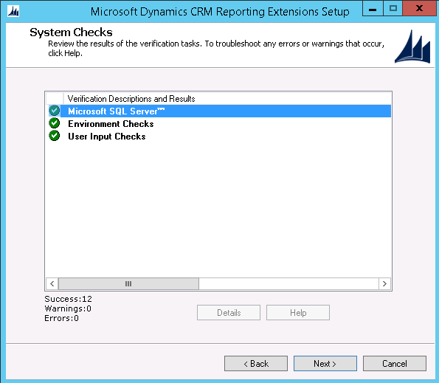

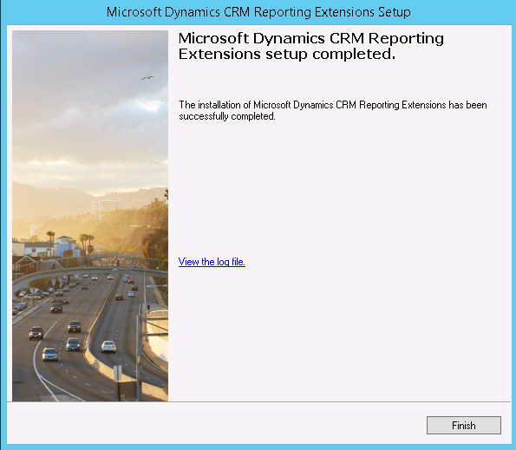

## Upgrade Dynamics CRM 2016

To upgrade Dynamics CRM 2016, follow the below steps:

1. To use a downloaded version of the “CRM2016-Server-KB4494402-ENU-Amd64.exe” update installer from the installation artifacts for this section, skip ahead past the next step.
2. Alternatively, visit the web site at https://www.microsoft.com/en-us/download/details.aspx?id=100776 to download the necessary installation file. Within the available file list, select “CRM2016-Server-KB4494402-ENU-Amd64.exe” and then choose “next” to start the download.  
   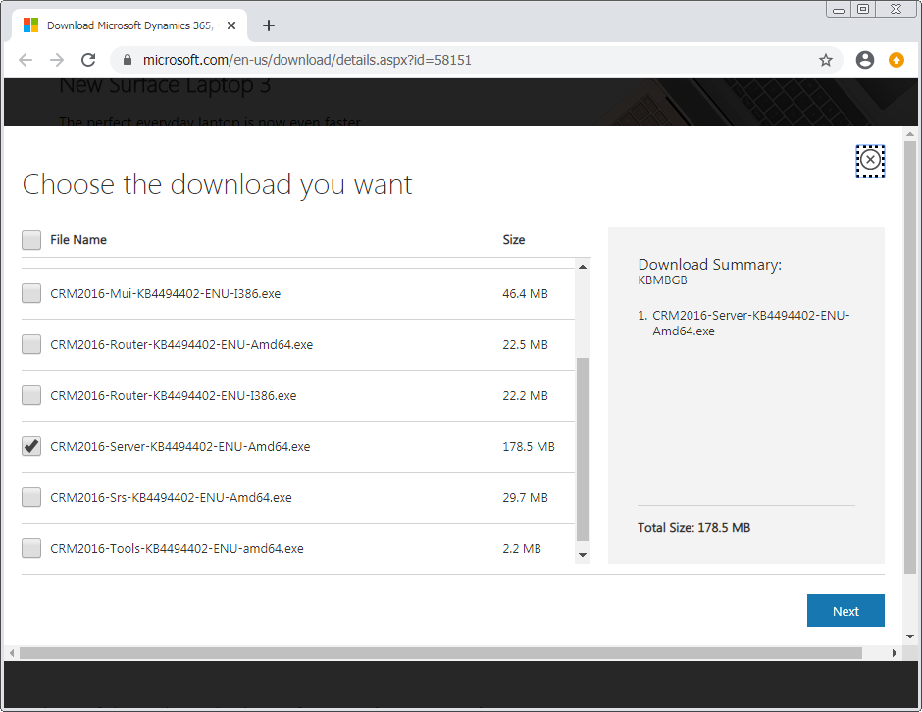
3. Using an account with a high level of permissions, such as “FPDHK\Administrator,” copy this file to the Dynamics CRM tier server and run it there. Follow the wizard to completion.  
   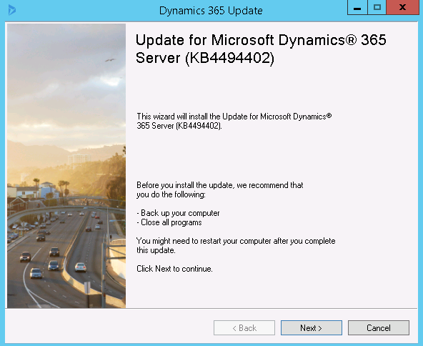
4. 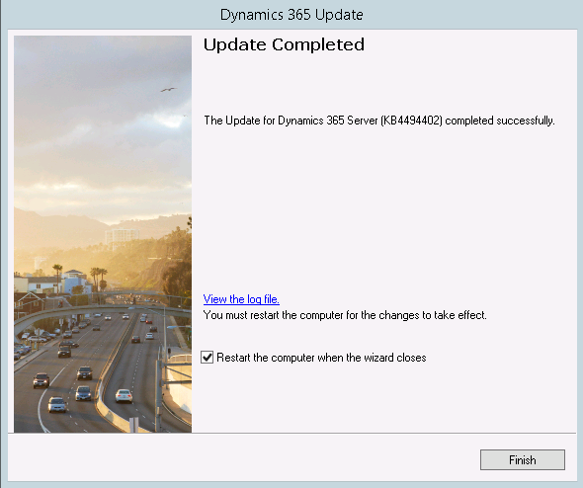
5.  Navigate to the Dynamics CRM by browser now, and check the software version. The version number should now be 8.2.5.4.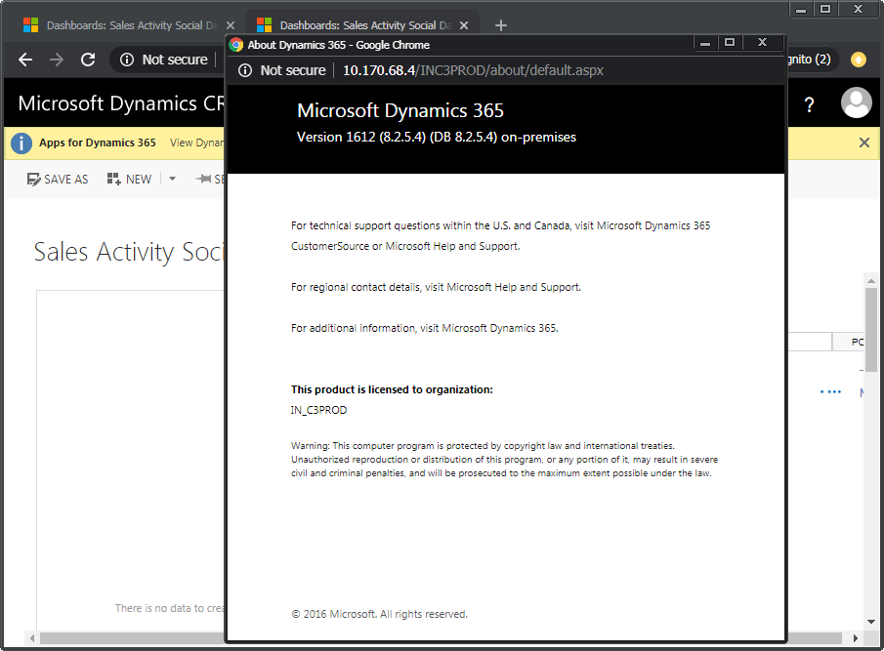
6. At this point, if the installation account is a controlled account such as “FPDHK\Administrator”, it is a good idea to add a second user to Dynamics CRM for the remaining deployment work. This second account can be the installation user’s own Active Directory account, for example. And, this account should be granted the “system administrator” role within Dynamics CRM. For specifics of adding a new user in Dynamics CRM, refer to “appendix: add new user.”

## Upgrade Dynamics SSRS Connector

To upgrade the Dynamics SSRS Connector, perform the following steps:

1. To use a downloaded version of the “CRM2016-Srs-KB4494402-ENU-Amd64.exe” update installer from the installation artifacts for this section, skip ahead past the next step.
2. Visit the web site at https://www.microsoft.com/en-us/download/details.aspx?id=100776 to download the necessary installation file. Within the available file list, select “CRM2016-Srs-KB4494402-ENU-Amd64.exe” and then choose “next” to start the download.  
   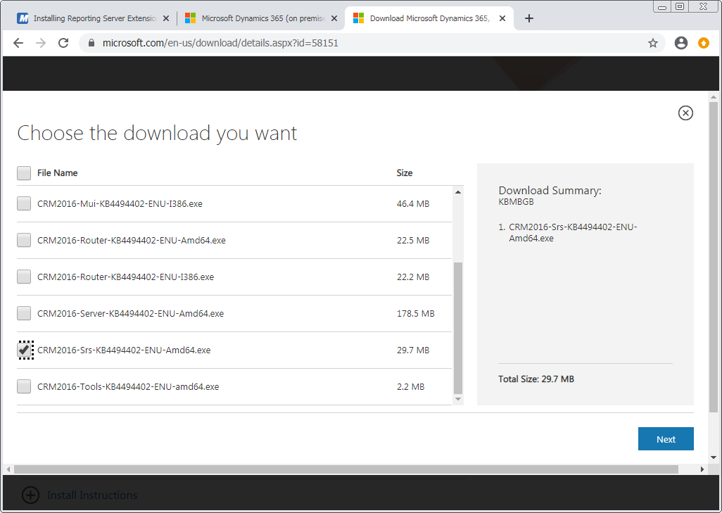

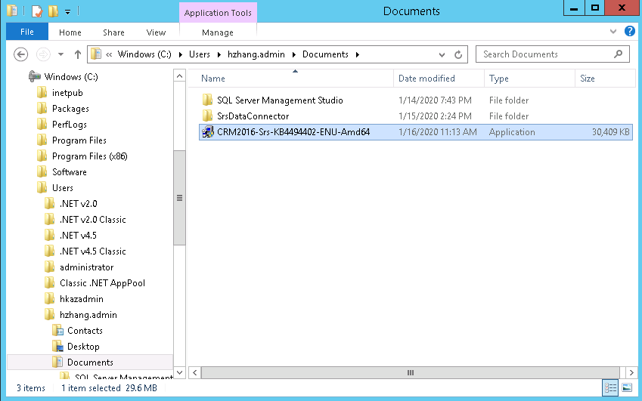

1. Using an account with a high level of permissions, such as “FPDHK\Administrator,” copy this file to the data tier server and run it there. Follow the wizard to completion.  
   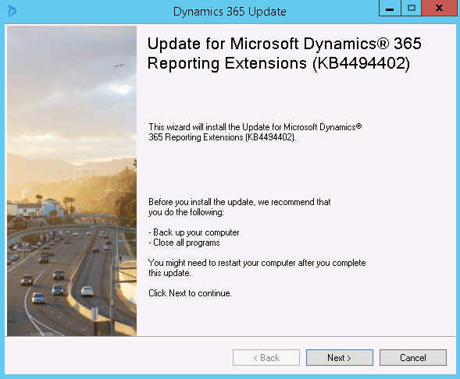  
     
   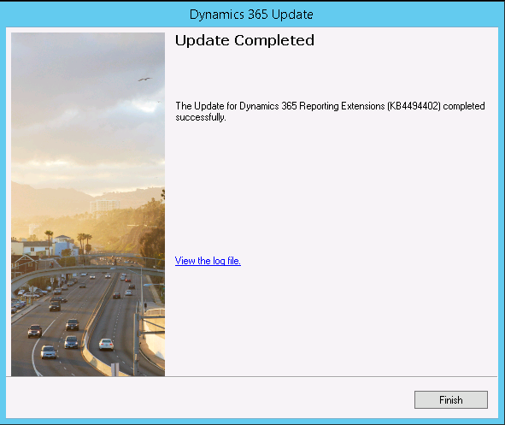

## Configure Claims Based Authentication

To configure claims based authentication, follow these steps:

1. A prerequisite setup for claims based authentication configuration is that the main Dynamics CRM site has to have an HTTPS binding. Open the IIS application on the Dynamics CRM tier server.
2.  In order to carry out this step, the wildcard SSL certificate needs to have been added to the web application tier server beforehand, by someone with privileges such as the infrastructure team.   
   Add an HTTPS binding to the site “Microsoft Dynamics CRM.” The following values should be used for the “add site binding” form:
   * Type: https
   * IP address: all unassigned
   * Port: 443
   * SSL certificate: *.savills.asia

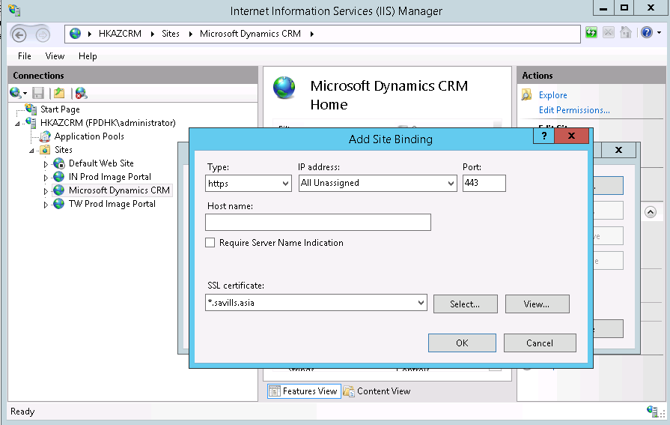

1. Afterwards, remove the original HTTP binding to the same site.
2. Open “Dynamics 365 Deployment Manager.” Open the “properties” dialog for the main “Dynamics 365” node.

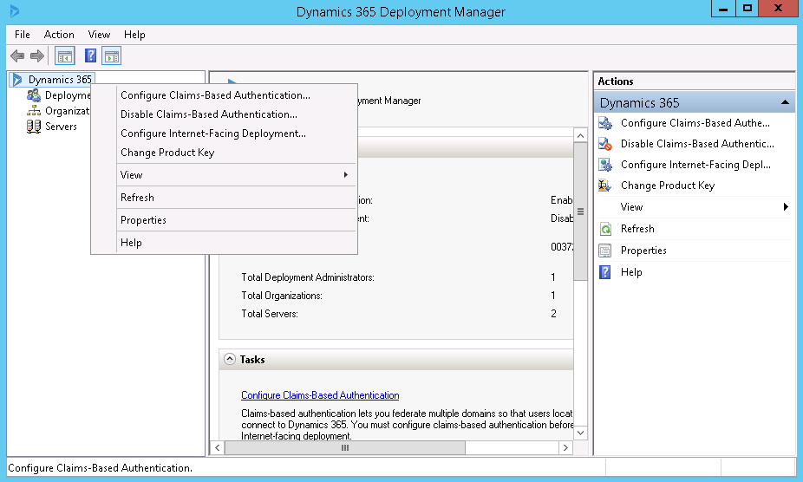

1. Select the “web address” tab. Select “HTTPS” for the binding type, and enter the required fields as well. For this example, these values are:

Web application server: internalprodcrm.savills.asia

Organization web service: internalprodcrm.savills.asia

Discovery web service: internalprodcrm.savills.asia

Deployment web service: internalprodcrm.savills.asia:443  
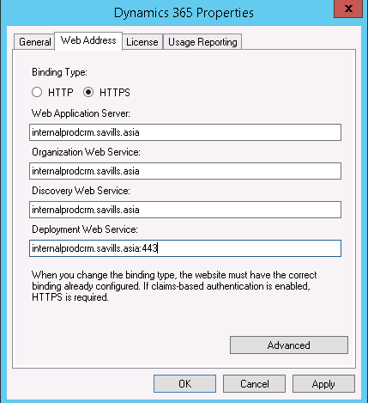  
Select “apply” the to adopt changes.

1. Select the main node of “Dynamics 365” in the deployment manager, and invoke the action of “configure claims-based authentication.”

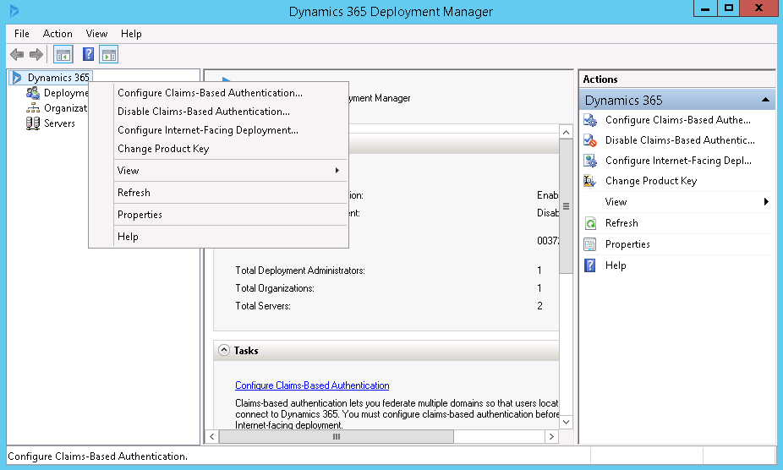

1. In the step of “specify the security token service,” enter the following for the “federation metadata URL” field:  
   https://adfs.savills.com.hk/federationmetadata/2007-06/federationmetadata.xml

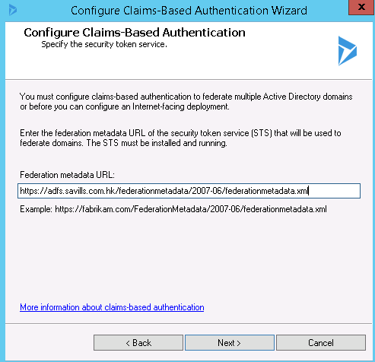

1. In the step of “specify the encryption certificate,” select the wild card certificate “*.savills.asia”.

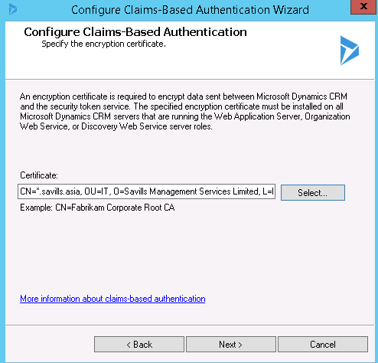

1. Follow through with the rest of the wizard.   
   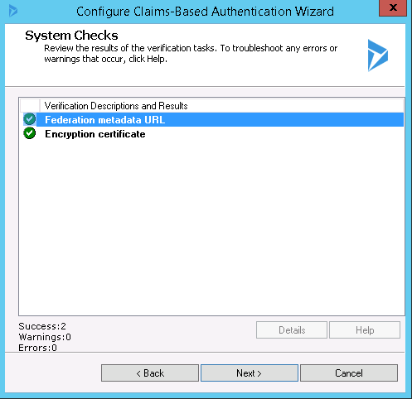 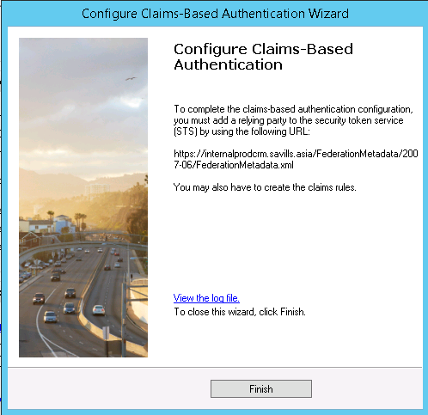
2. Make a note of the URL in the final step, and verify this URL in a browser for availability of the content.

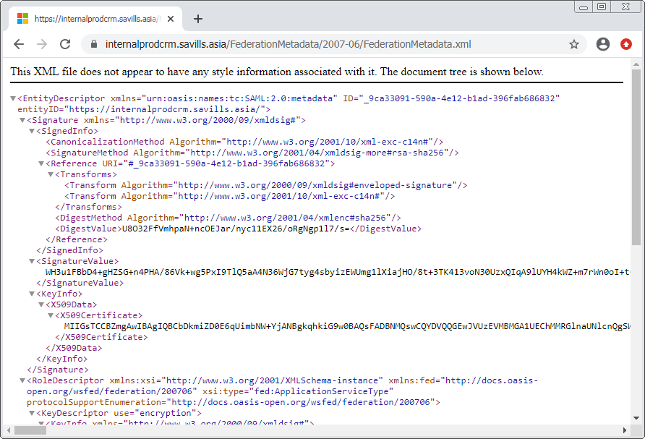

 Provide this URL to the infrastructure team to setup ADFS authentication. Proceed after ADFS authentication has been completed, as much of the remaining sections depend on this feature.

1.  The internal DNS entry has to be added by those with privileges such as the infrastructure team. In this example, the entry to add is for having “internalprodcrm.savills.asia” point to the web application tier server.

For Example



1.  Within a web browser on a client, navigate to the internal secure address. For example, this is  
   https://internalprodcrm.savills.asia  
   Enter credentials for the installation user or the second user as added earlier when prompted to sign in. Verify that the sign in is successful and takes the user to within the CRM application.

## Configure Internet Facing Deployment

To configure internet facing deployment, use the following steps:

1. Sign in to the Dynamics CRM tier server using an account with “deployment administrator” rights. For instance, this can be the account used to install Dynamics CRM earlier.
2. Start the “Dynamics 365 Deployment Manager” application.
3. Select the top-level node of “Dynamics 365” within the available hierarchy. Then from the available actions on this node, invoke “configure internet-facing deployment…”.  
   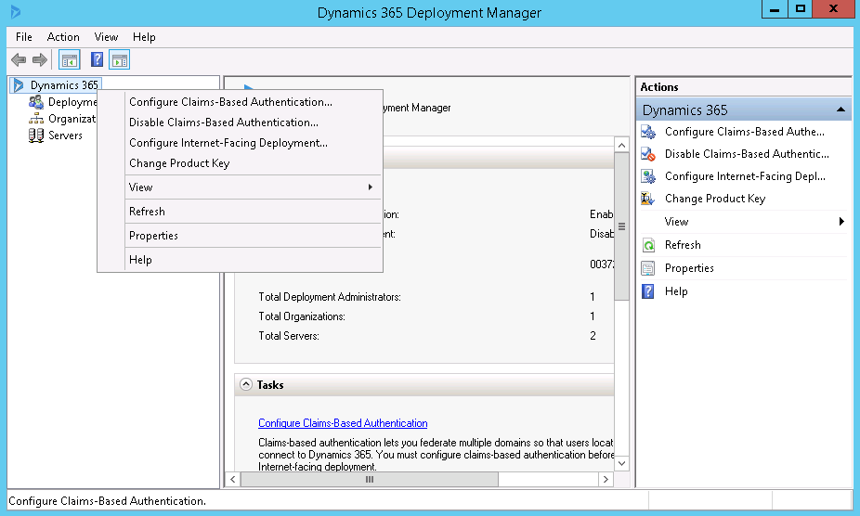
4. In the first step of the wizard, fill in the required fields. For example, the following values are used here:
   * Web application server domain: savills.asia
   * Organization web service domain: savills.asia
   * Discovery web service domain: discoprodcrm.savills.asia

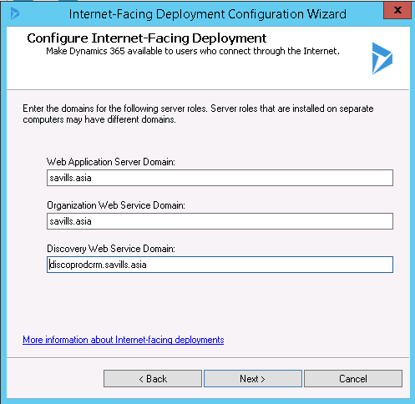

1. In the second step of the wizard, fill in the required field. For example, the following value is used here:
   * External domain: authprodcrm.savills.asia

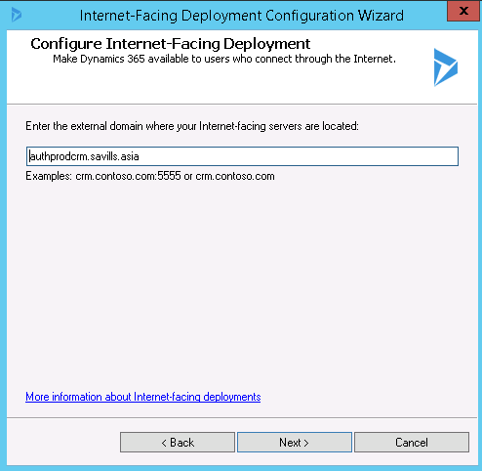

1. Step through the rest of the wizard to finish the setup.  
   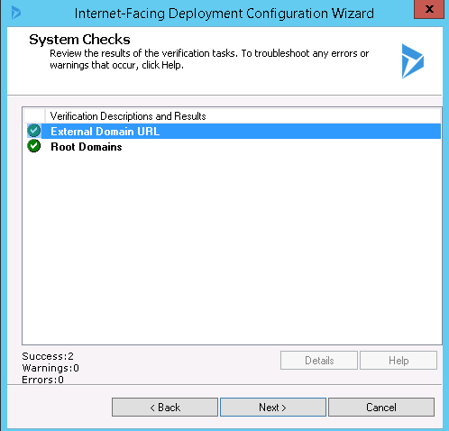 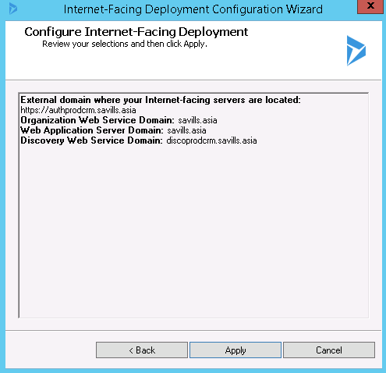 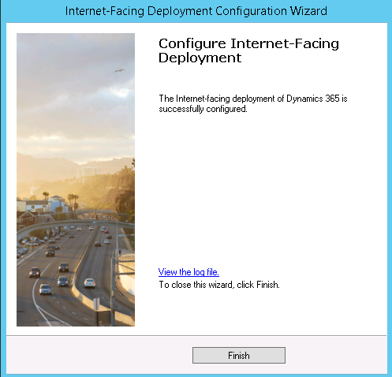
2.  The DNS entry can be added at or before this point by those with privileges such as the infrastructure team. In this example, the entry to add is for having “inc3prod.savills.asia” point to the web application tier server. Above mentioed image is example of DNS entry

 From a web browser, navigate to the proper URL of the initial organizational site created above. For this example, this is “https://inc3prod.savills.asia”. Verify that an ADFS style login screen is now shown. 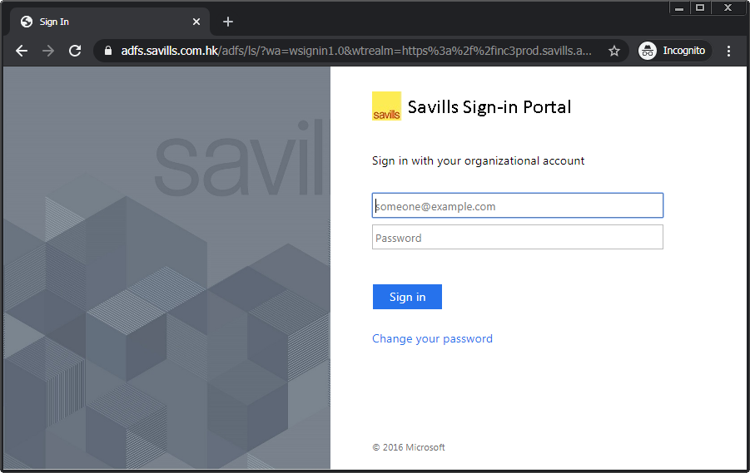  
Also attempt to login using the installation account. The login should succeed.

# Deploy CommercialCube Customizations

This section covers the importation of custom solutions and data into Dynamics CRM.

## Import Custom Solutions

To import the custom solutions into Dynamics CRM, follow the below steps:

1. Navigate to the site URL for a newly created organization. In this example, it is “https://inc3prod.savills.asia”. Sign in to Dynamics CRM using an account has the “system administrator” role. For example, the account used for earlier CRM installation can be used.
2. From the “settings” menu section, under the “customization” subsection, select the “solutions” menu item.  
   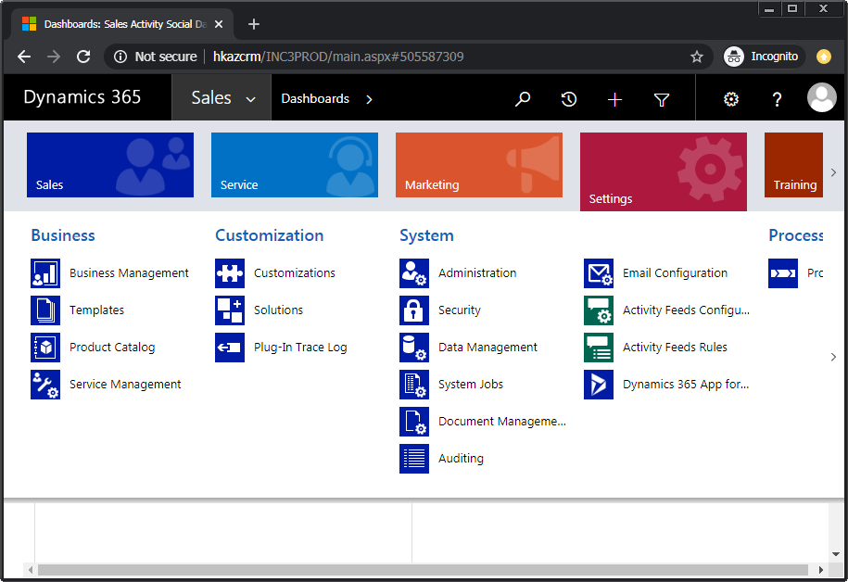
3. On the “all solutions” page, select the “import” menu command to open the “import solution” wizard.
4. Use the “choose file” command to select the “16.3.001.00006-SalesforceMarketingCloud2016-English-Managed.zip” file from the installation artifacts and follow the wizard’s steps.  
   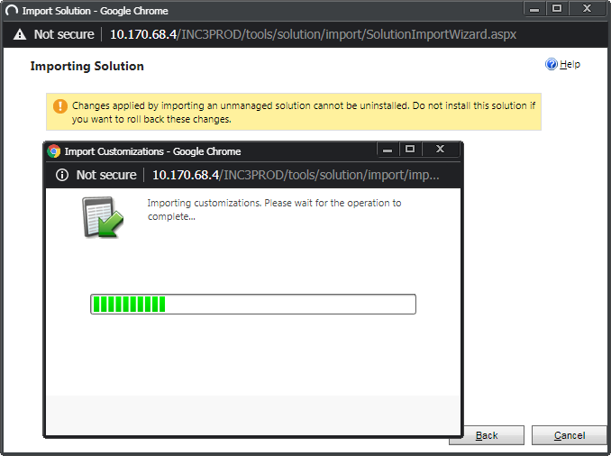
5. On the last page of the wizard, use the “download log file” command to keep a record of the solution import process.

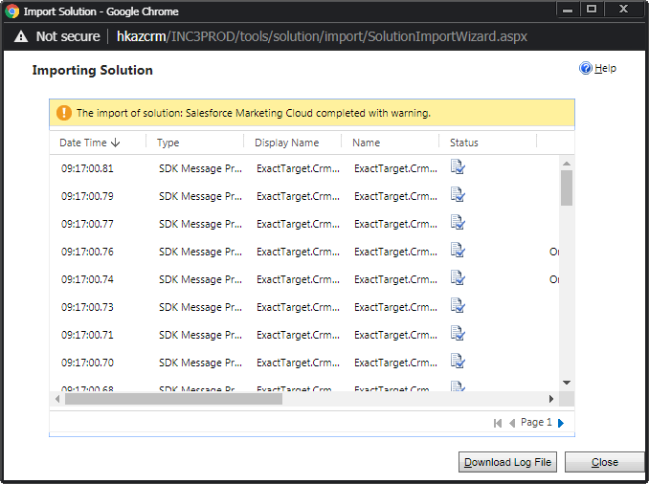

1.  At this point, an entry with the name “ExactTarget” should show on the solutions list.
2. Repeat the above steps for the following files in the installation artifacts:

* AdxstudioCRM2011ProductivityPack.zip
* RibbonWorkbench2016_3_1_177_1_managed.zip

1. For the below unmanaged solutions, the steps are similar as for managed solutions.

* GatewayExporttoSavillsAPAC_1_0_0_0.zip
* GatewayExporttoSavillsAPACCustomActions_1_0_0_0.zip
* GatewaydisableKLeberandenableGoogleMaps_1_0_0_0.zip

On the last stage of the wizard, the additional step of invoking the “publish all customizations” command needs to be made.  
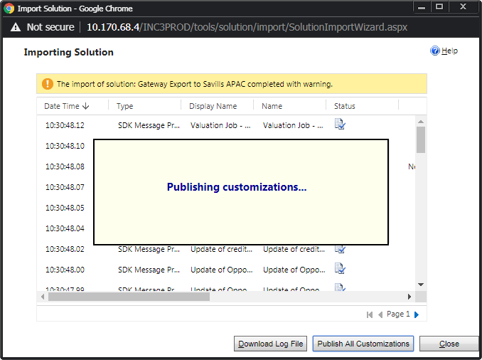

1.  After all the solutions have been imported, verify that their corresponding entries should be then be in the “all solutions” list.  
   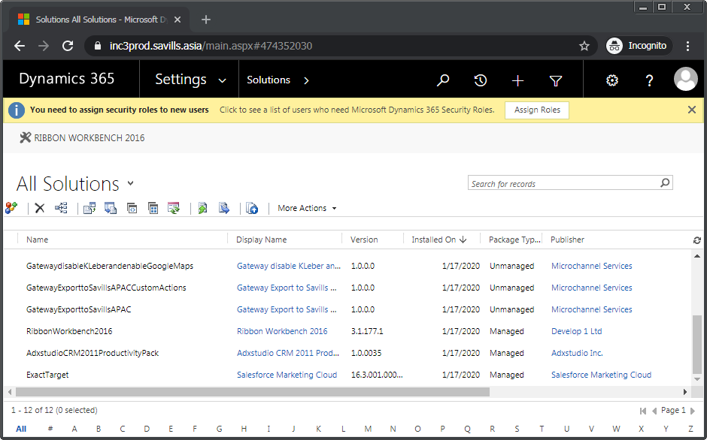

## Import Configuration Data

To import configuration data, take the following steps:

1. To use a downloaded version of the “DataMigrationUtility.exe” from the installation artifacts for this section, skip ahead past the next step.
2. Alternatively, download Microsoft Dynamics 365 (v8.x) Software Development Kit (SDK) at this link, <https://www.microsoft.com/en-us/download/details.aspx?id=50032>. Extract the downloaded SDK. From within the extracted folder, navigate to the “Tools” folder, and the “ConfigurationMigration” folder.
3. Run the “DataMigrationUtility.exe” application.
4. For the login dialog, enter the required fields. For this example, the server-related values entered are:
   * Deployment Type: On-premises
   * Server: inc3prod.savills.asia
   * User SSL: checked
   * Authentication Source: Internet-facing deployment (IFD)

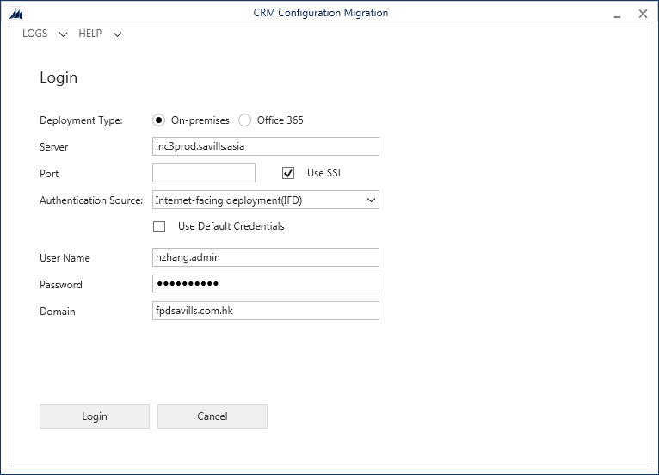

After connecting, choose the target organization from a list, if there is more than one organization for this Dynamics CRM instance. During the initial Dynamics CRM installation, no selection should be available.

1. In the next step, use the “…” control to browse for “data.zip” in the installation package and open it.  
   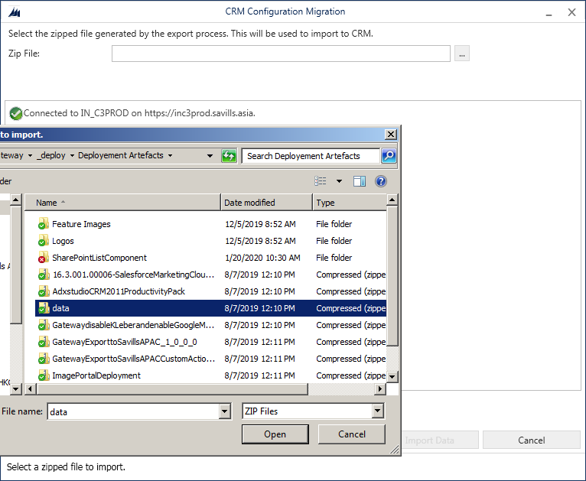
2. Go ahead and select “import data” and follow the wizard through to the end. Review the results and choose “exit.”  
   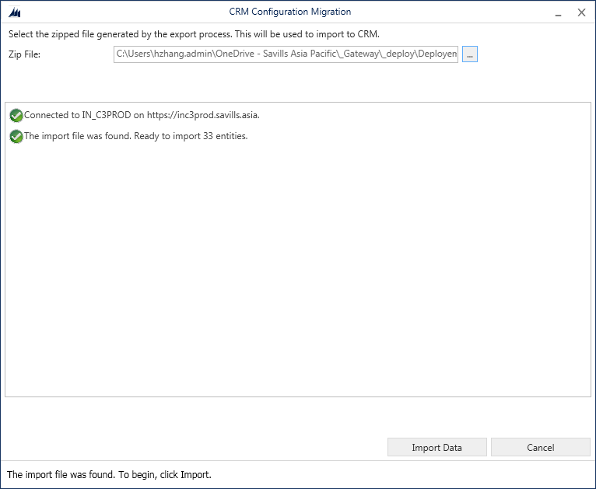  
      
   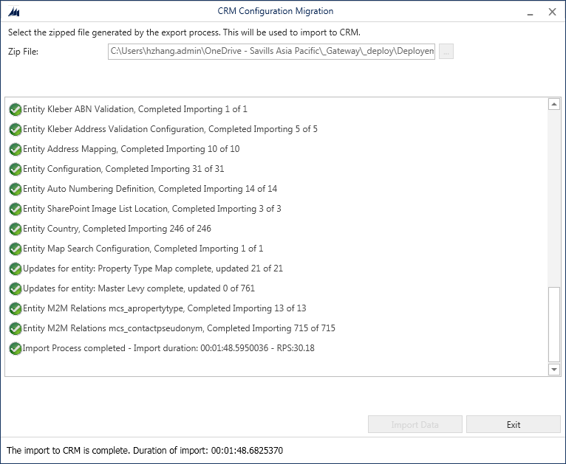

## Import Queues Data

To import queues data, follow these steps:

1. In Dynamics CRM, go to the “settings” menu section, under the “system” sub-section, select the “data management” option.  
   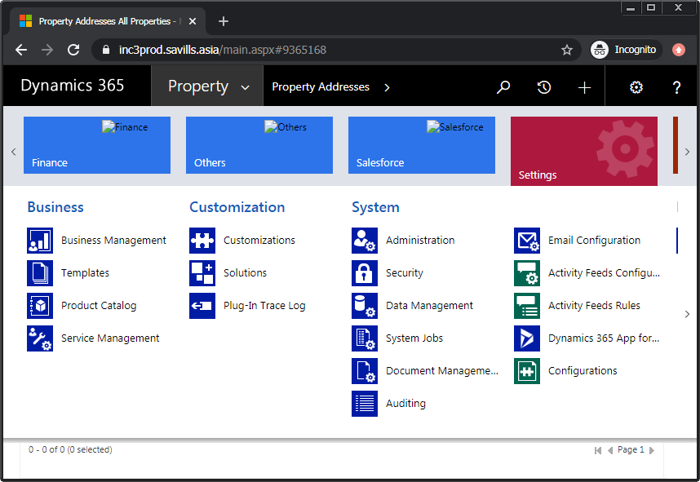
2. Within the “data management” page, choose the “imports” option.  
   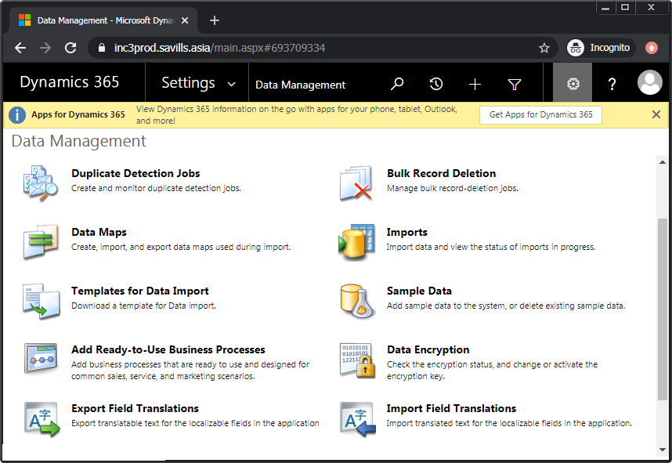
3. From the “my imports” page, invoke “import data” menu command to bring up the “upload data file” dialog.
4. Use the “choose file” control to browse for the file “queues.csv” within the installation package, and continue by selecting “next.” Then select “next” again.

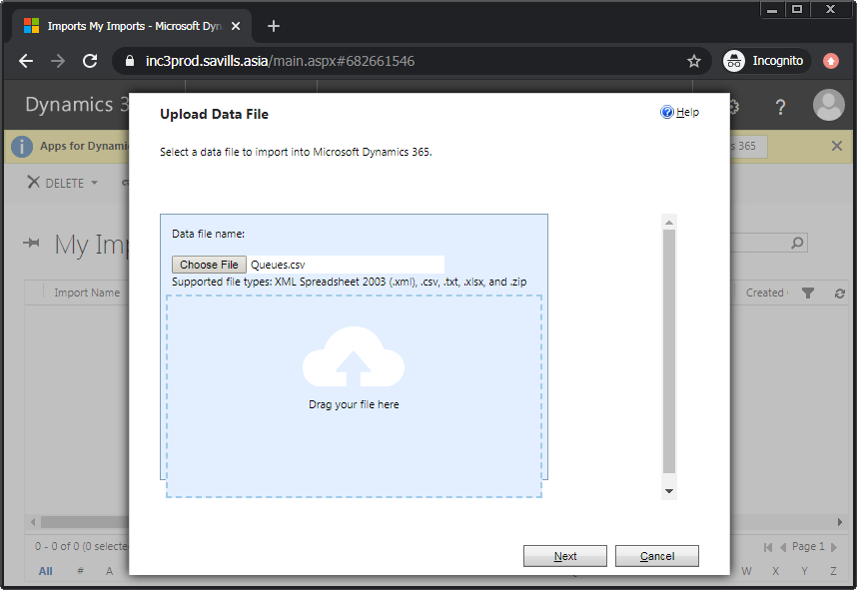   
  
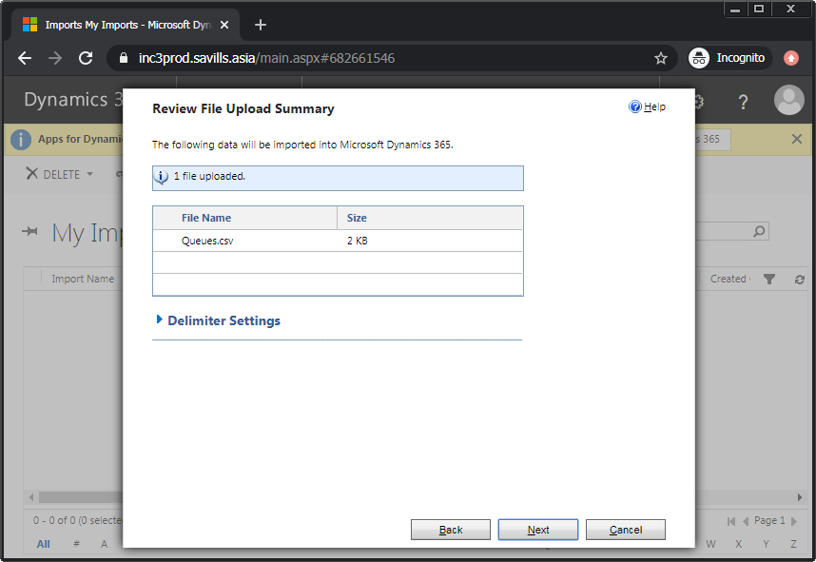

1. In the subsequent “map record types” step, select “queue” from the “Microsoft Dynamics 365 Record Types” drop-down, and choose “next.” Then choose “next” again to accept the default value of “Default (Automatic Mapping).”

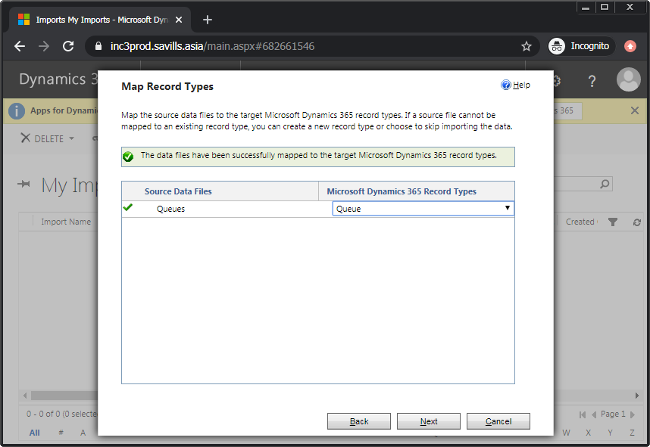 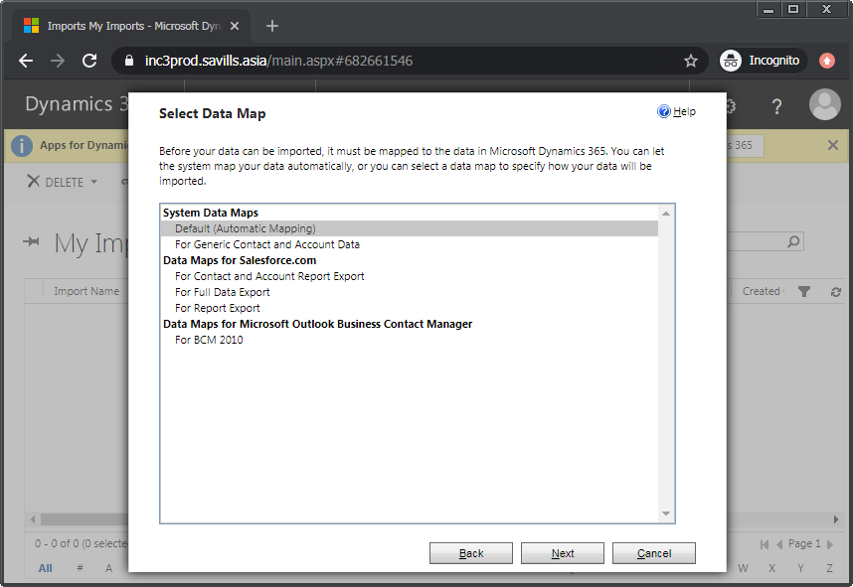

1. Accept the defaults of the remaining steps to complete the wizard.  
   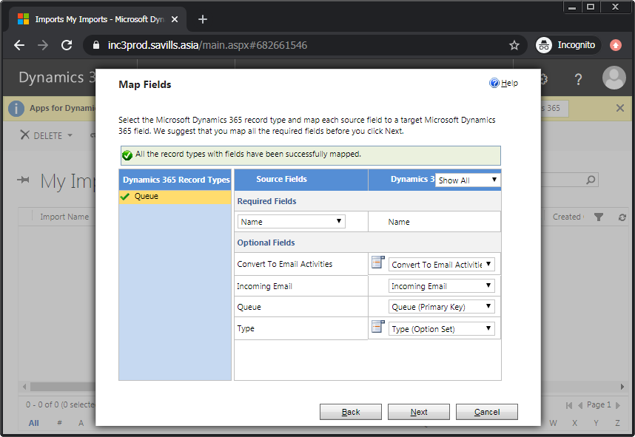   
     
   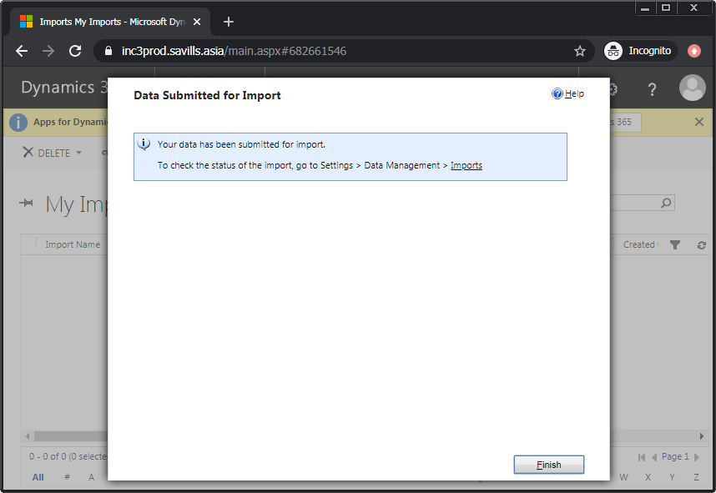
2. At this point, the “queues.csv” file shows up in the “my imports” list. The entry “Successes” has a count of 0 initially with the “status reason” remaining as either “parsing” or “transforming.” After the process is completed, this becomes an actual “successes” count and “completed” is shown.  
   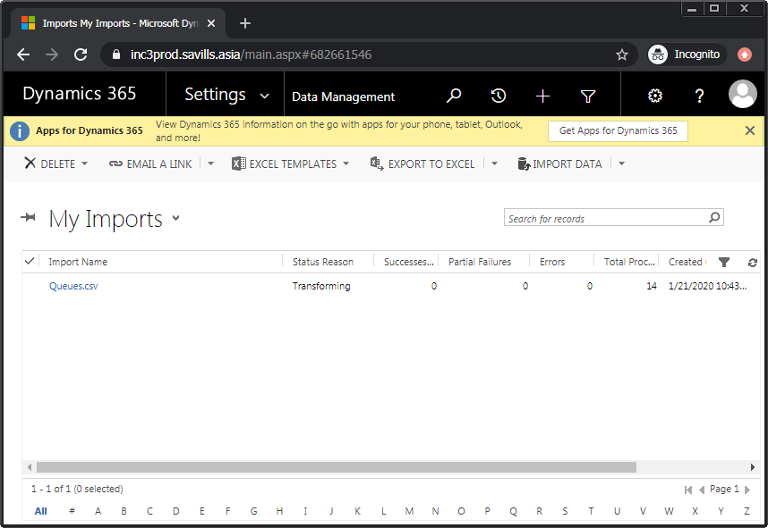  
     
   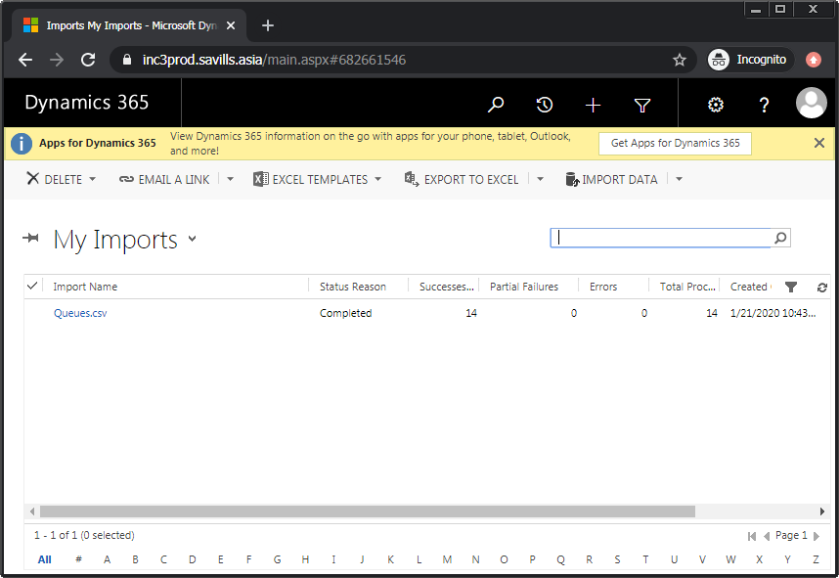
3.  To verify that the queues have been imported, go to the “settings” menu section, under the “business” sub-section, choose the “business management” option. In the subsequent page, choose the “queues” option. Then, in the “my active queues” page, check that the new entries are now shown.

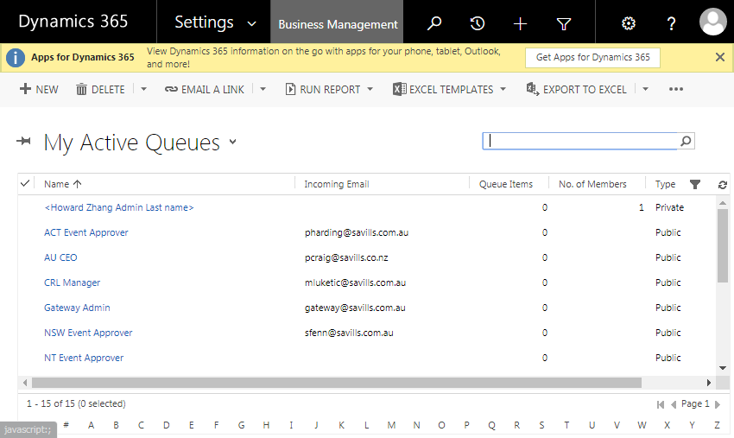

## Import Teams Data

To import the teams data, follow these steps:

1. Make a copy of Teams file from installation artifacts.
2. The values of the “Business Unit” and “Administrator” columns must be changed in the file before the import takes place.  
   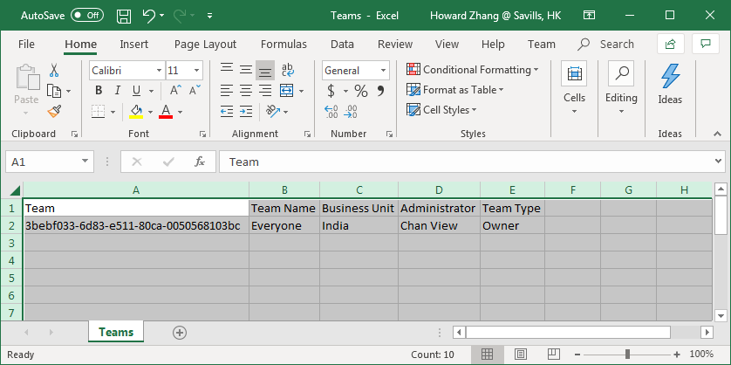

Sign in to Dynamics CRM. Look up the value for “business unit” by going to the “settings” menu section, under the “system” sub-section, select “security” option. From the security page, choose “business units” to open the “business units” page. Note down the name of the single entry in the list. In this example, this is “IN_C3PROD”.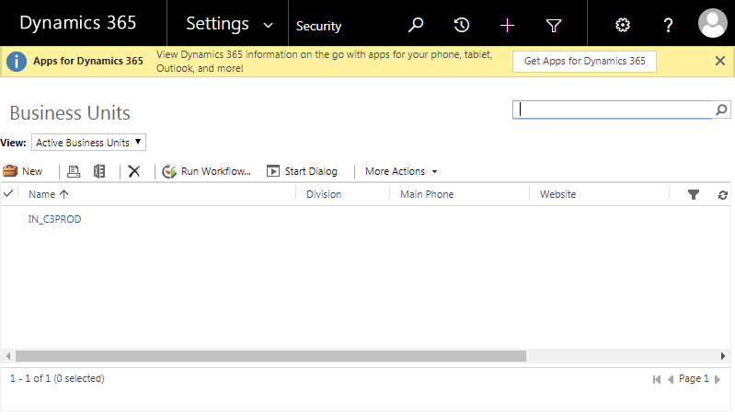

1. Look up the value for “administrator” by referring again to the security page, choose the “users” option to open the “users” page. Note down the full name of the user who is performed the Dynamics CRM installation.  
   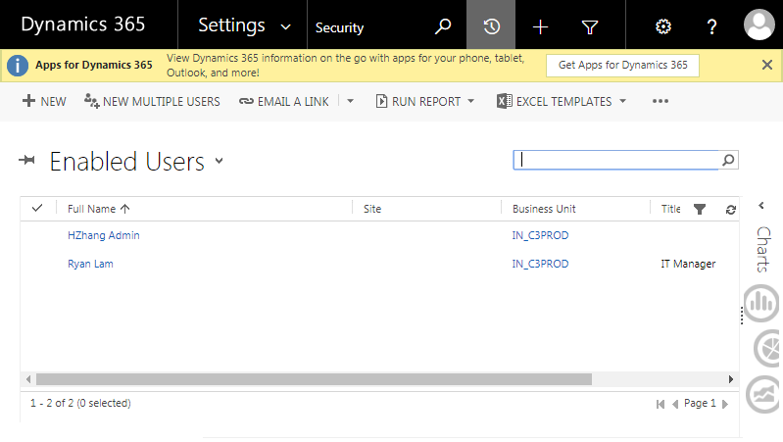

After updating the two mentioned values from the noted down values, save the “teams.csv” file.   
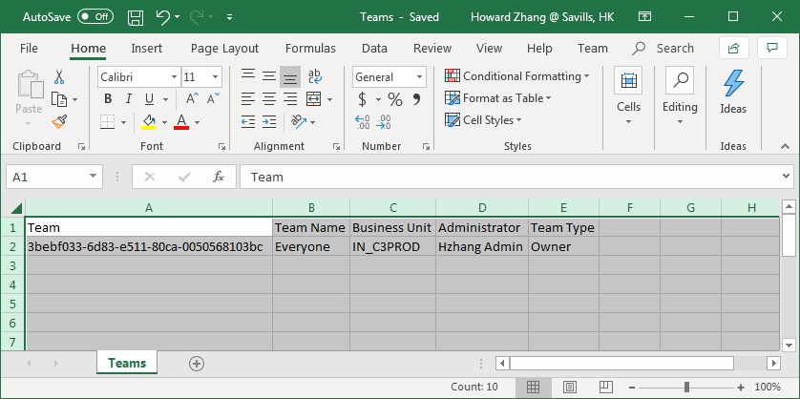

1. In Dynamics CRM, go to the “settings” menu section, under the “system” sub-section, select the “data management” option.
2. From the “my imports” page, invoke “import data” menu command to bring the “upload data file” dialog.
3. Within the “data management” page, choose the “imports” option.
4. Use the “choose file” control to browse for the file “teams.csv” within the installation package, and continue by selecting “next.” Then select “next” again.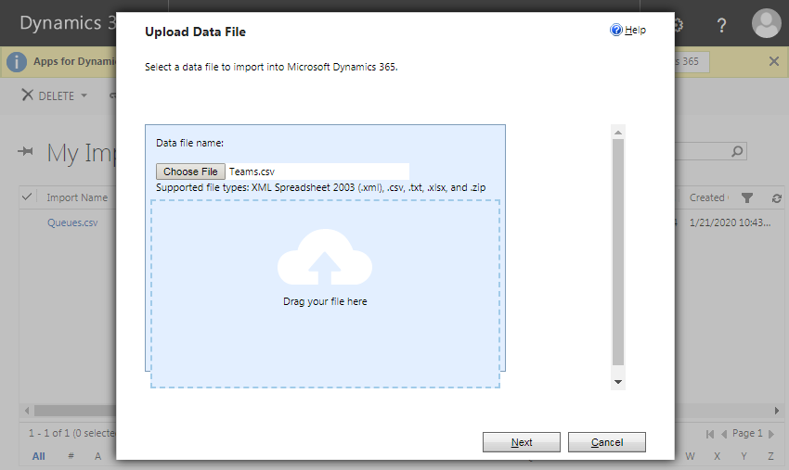
5. In the subsequent “map record types” step, select “team” from the “Microsoft Dynamics 365 Record Types” drop-down, and choose “next.” Then choose “next” again to accept the default value of “Default (Automatic Mapping).”

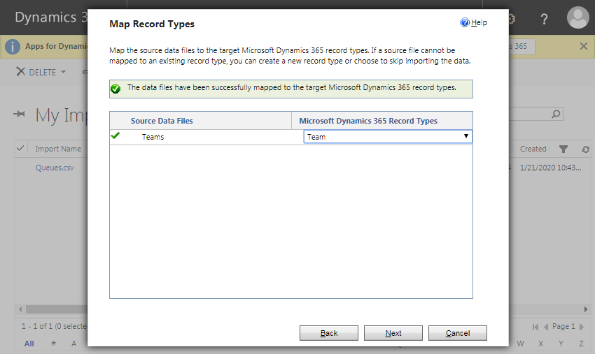

1. Accept the defaults of the remaining steps to finish the wizard.  
    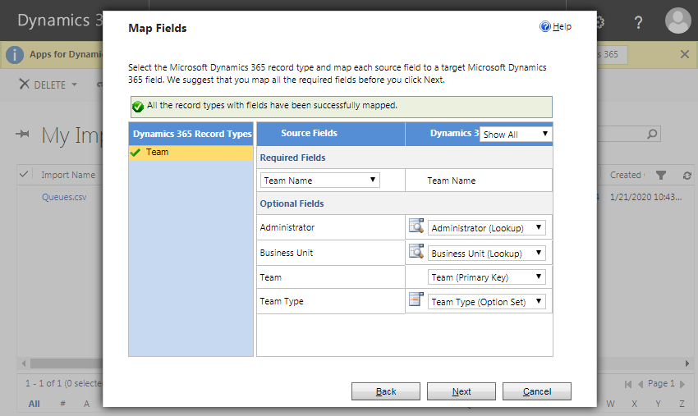

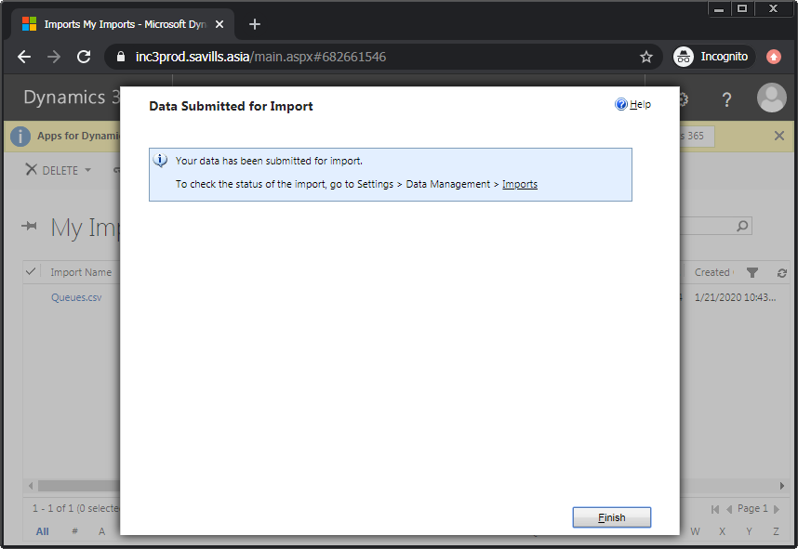

1. At this point, the “teams.csv” file shows up in the “my imports” list. The entry for “Successes” is 0 initially. After processing is done, this becomes an actual “successes” count and “completed” status are shown.  
   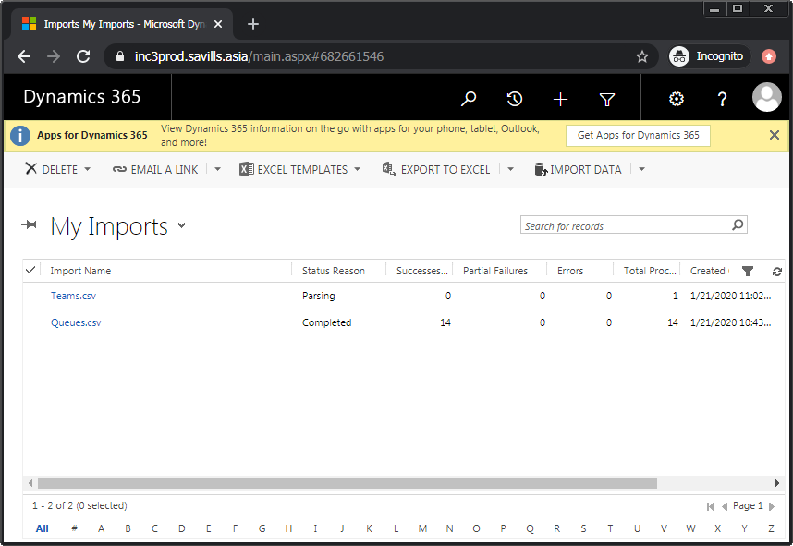  
     
   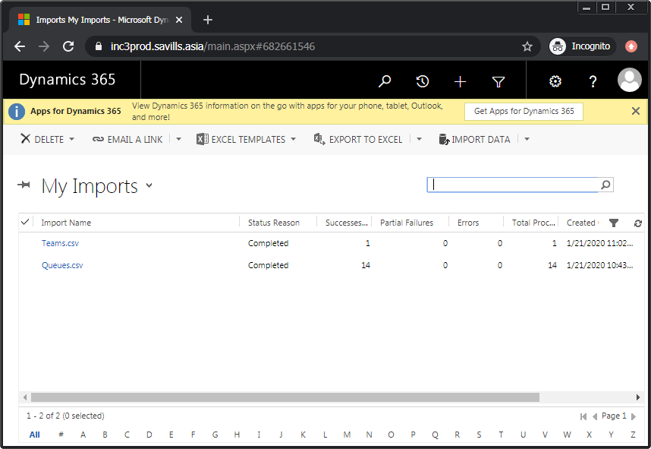
2.  To verify that the team has been imported, go to the “settings” menu section, then choose “security”, then choose “teams.” In the subsequently displayed “local business teams” page, check that new entry is now shown.

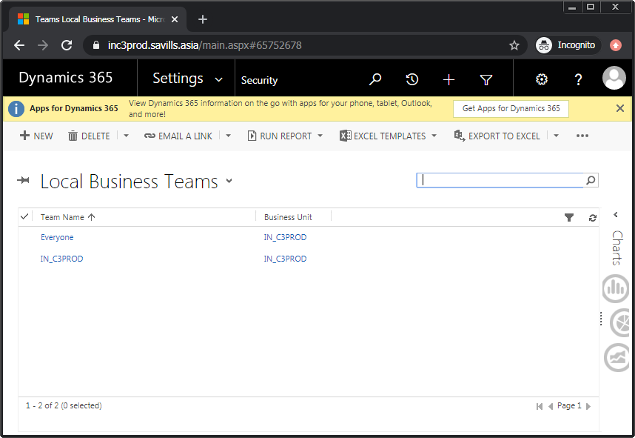

## Activate Processes for Custom Solutions

To activate processes for the custom solutions imported earlier, follow the below steps:

1. From the “settings” menu section in Dynamics CRM, under the “customizations” sub-section, select the “solutions” option to view all the imported solutions from earlier steps.  
   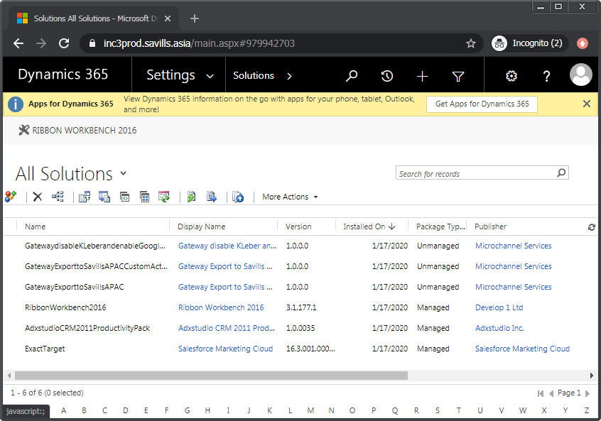
2. Locate and open the “Gateway Export to Savills APAC” solution. Further select the “processes” node to view all of the solutions’s processes.
3. Sort the processes according to “status” so that the “draft” status entries appear first. Select all these entries that have “draft” status.
4. Invoke the menu command of “activate.” Then once again confirm this action by choosing “activate” in the subsequent dialog.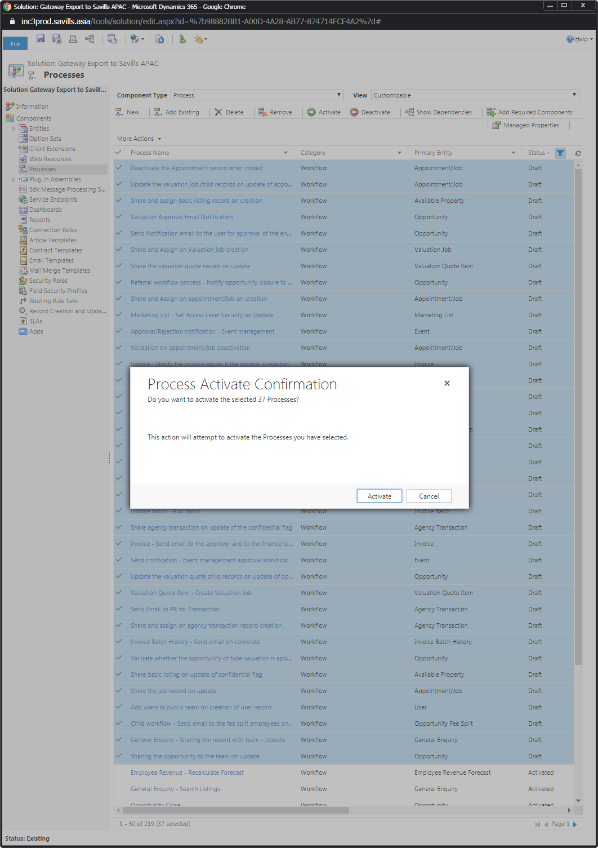
5.  Verify that all the processes are now activated. If verification fails, refer to the troubleshooting steps further down in this section.
6. Perform the same procedure as above for the “Gateway Export to Savills APAC – Custom Actions” solution.  
   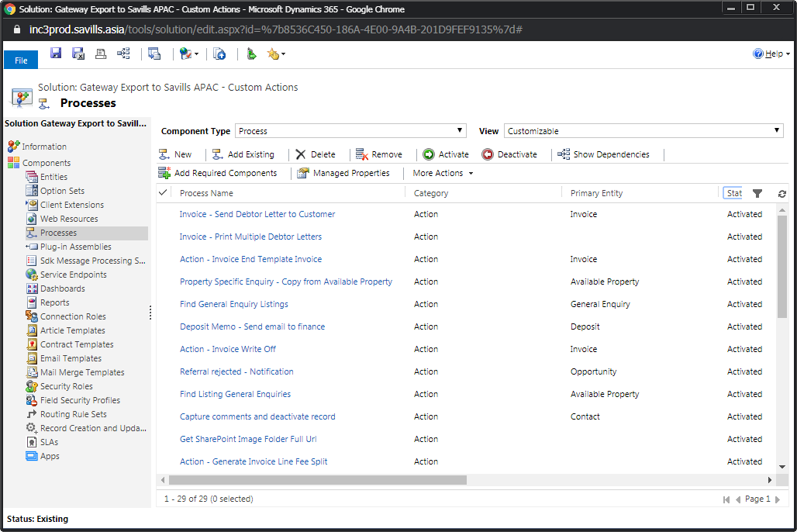  
     
   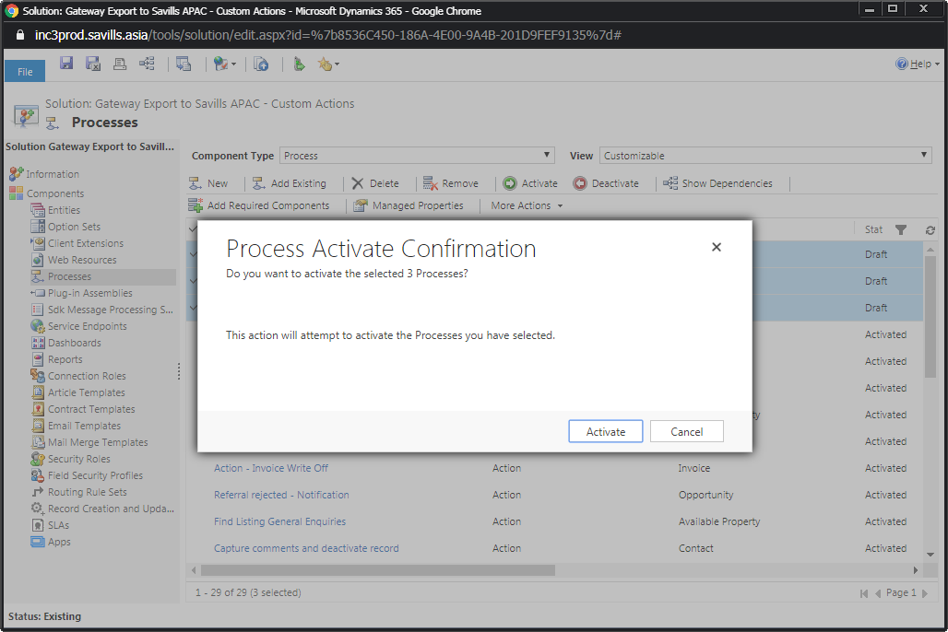
7.  Verify that all the processes for this solution are now activated.
8. For the above steps, if the base currency of the organization being installed to is not the Indian Rupee, then some of the processes will fail to activate. These will remain in “draft” status. Open each of these to fix the issue. For this example, the organization has its base currency in Indonesian Rupiah, and thus the process’s page shows errors. Invoke “set properties” action for any step within that has an error symbol. There may be more than one problematic steps.  
   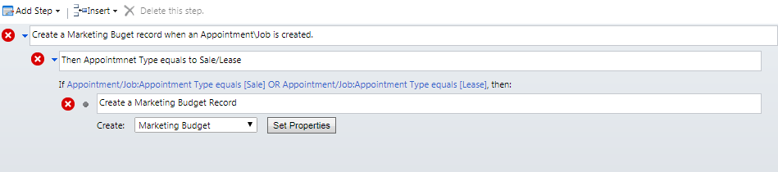
9. Inside the step’s detail page, change all the “currency” fields from “Rupee” to the current base currency. For this example here, change these to “Rupiah.”   
   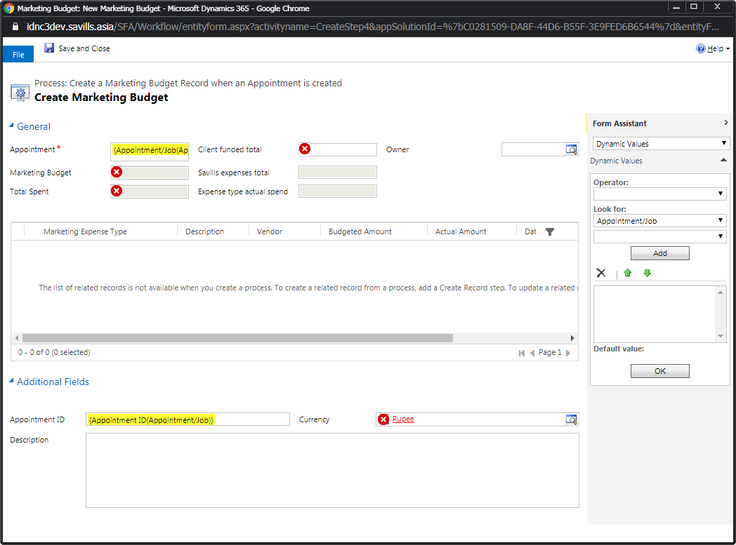  
   Once all the errors are removed, choose “save and close.”

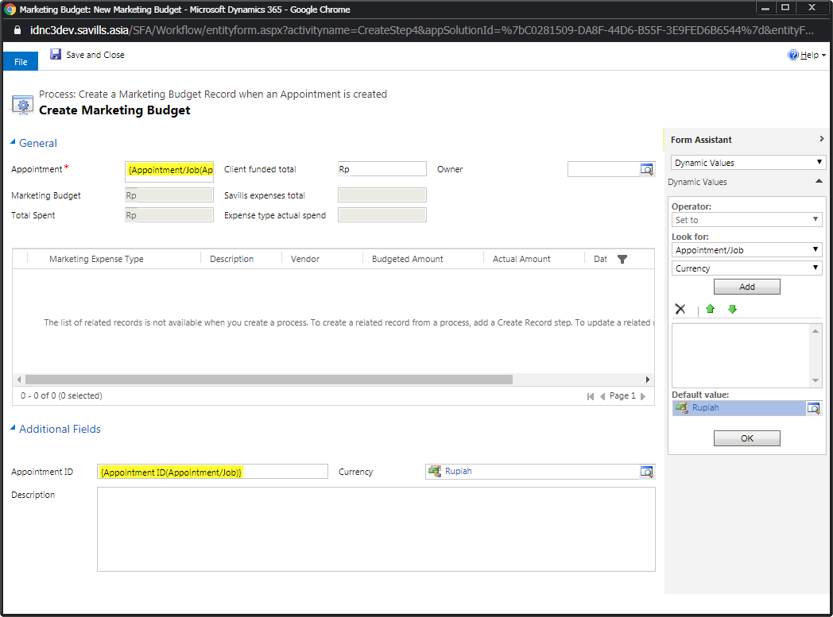

1. Back at the process level, check that errors are also no longer indicated. Choose the ”save and close” action for the process.  
   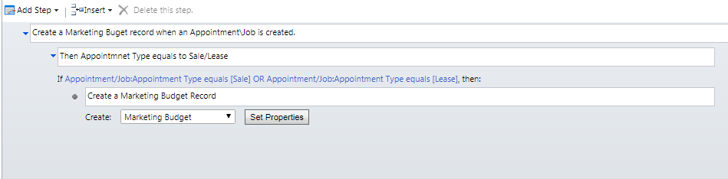
2. Back in the processes list view, select this just modified process. Choose the “activate” menu command. Repeat these steps for each process still in “draft” state.

# Setup SharePoint Integration

This section covers the configuration of SharePoint and setting up of required site collections.

## Create Site Collections

A prerequisite for SharePoint integration is that there needs to be a document collection and an image site collection set up initially, for each new organization. To achieve this, go through the following steps:

1. The web site that hosts the site collections has to have an HTTPS binding before the sites can be created. To achieve this, use an administrative account, such as “FPDHK\GatewayService,” to sign-in to the file storage tier server(share point server).
2. Open the Internet Information Services (IIS) Manager application.
3.  In order to carry out this step, the wildcard SSL certificate needs to have been added to the reporting tier server beforehand, by someone with privileges such as the infrastructure team.   
   Add an HTTPS binding to the site “Default Web Site.” The following values should be used for the “add site binding” form:
   * Type: https
   * IP address: all unassigned
   * Port: 443
   * SSL certificate: *.savills.asia

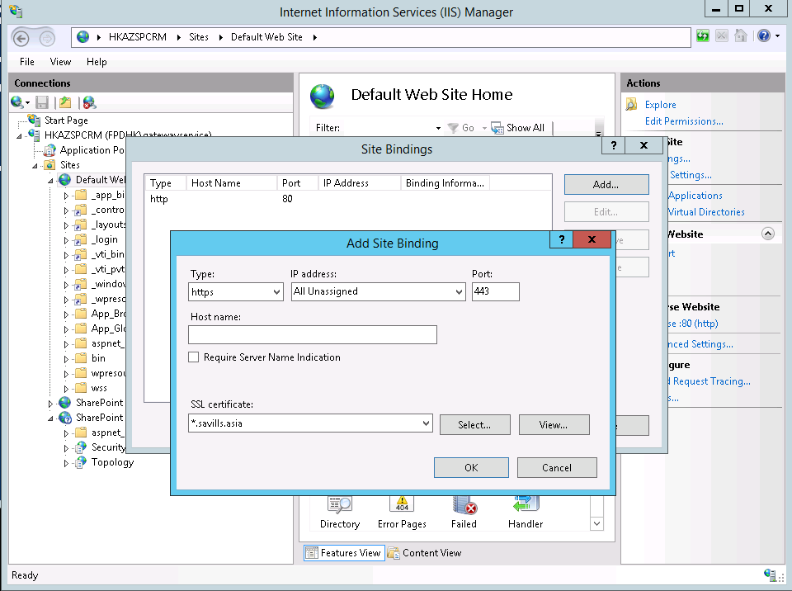

1. Afterwards, remove the original HTTP binding to the same site.
2. Copy the “make_spsite.ps1” script from the installation artifacts to the SharePoint server. Modify the first “New-SPSite” command by updating the command arguments of
   * Url
   * OwnerAlias
   * Name
   * Description
   * Template

, as required for the target country’s installation. For example, in the case of the current example, that is, India’s production installation, these are:

* + https://inc3proddocsp.savills.asia
  + FPDHK\GatewayService
  + IN_C3 PROD Documents
  + Stores India’s C3 PROD Documents
  + STS#0

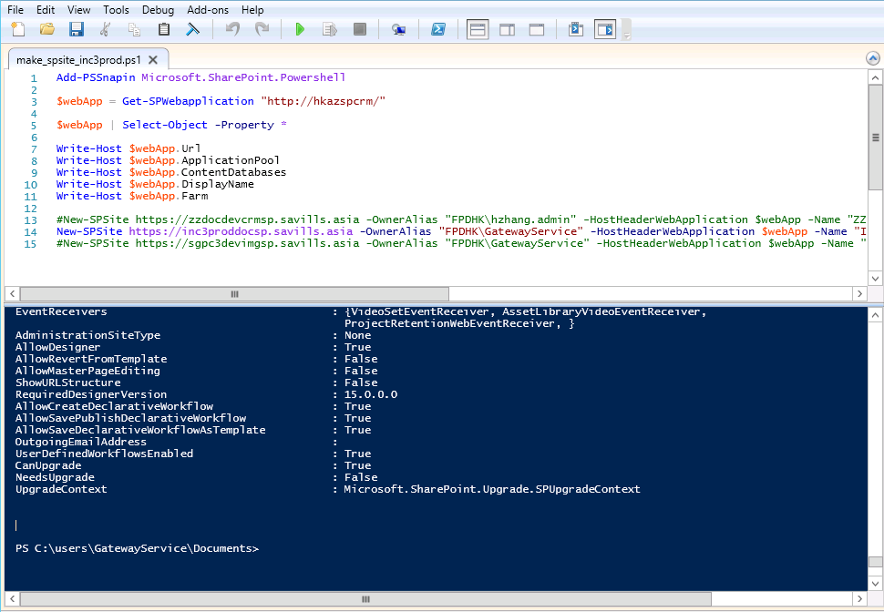

1. Leave the second “New-SPSite” command commented out and run the Powershell script. This creates a host-named collection for storing C3’s documents.
2. Comment out the first “New-SPSite” command before moving on to the second one.
3. Similar to before, modify the second “New-SPSite” command by updating command arguments as demonstrated above. This time, the modifications are to be appropriate for an image library site.  
   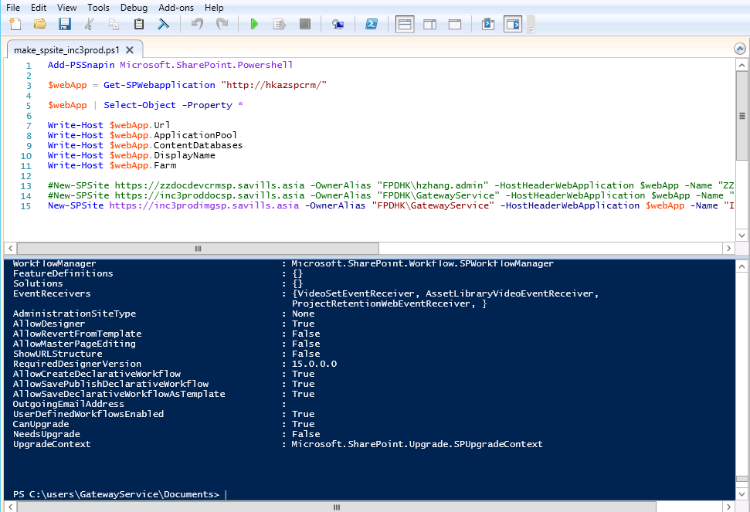
4. Run the Powershell script. This creates a host-named collection for storing C3’s images.
5.  From the central administration’s “site collection list,” verify that the two new site collections are now listed, indicating that they have been properly created.  
   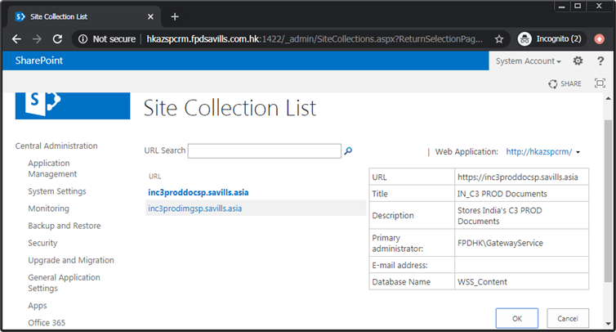
6.  Before proceeding, the URL specified for this site must have its corresponding DNS entry added by those who have the required privileges, such as the infrastructure team. Like   
    Copy the document site’s URL from the previous step. Verify that the site has been set up correctly by accessing this URL in a browser. When prompted for the first time, use the SharePoint administration account of “GatewayService” to sign in.  
   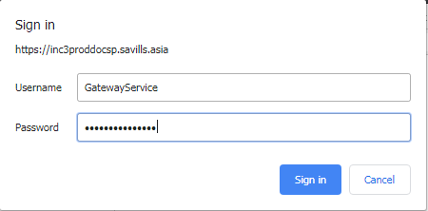

After sign-in, the document site’s home page should be shown.  
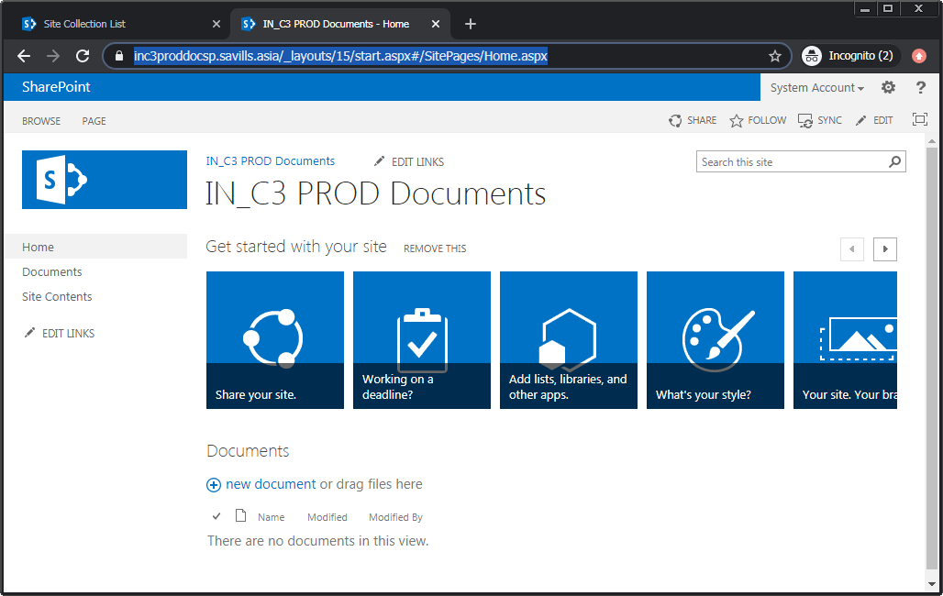

1.  Similarly, verify the image site as done above.  
   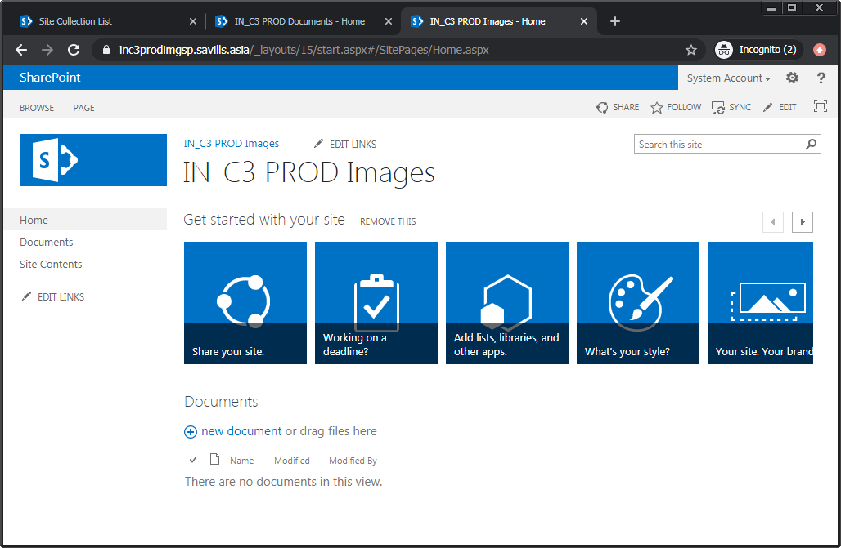

## Setup Automatic Permission Granting for Dynamics CRM User Accounts

To set up automatic SharePoint site permission granting for Dynamics CRM user accounts, complete the following steps:

1. Sign in to the SharePoint document site created in the previous section, and navigate to the “site settings” page.   
   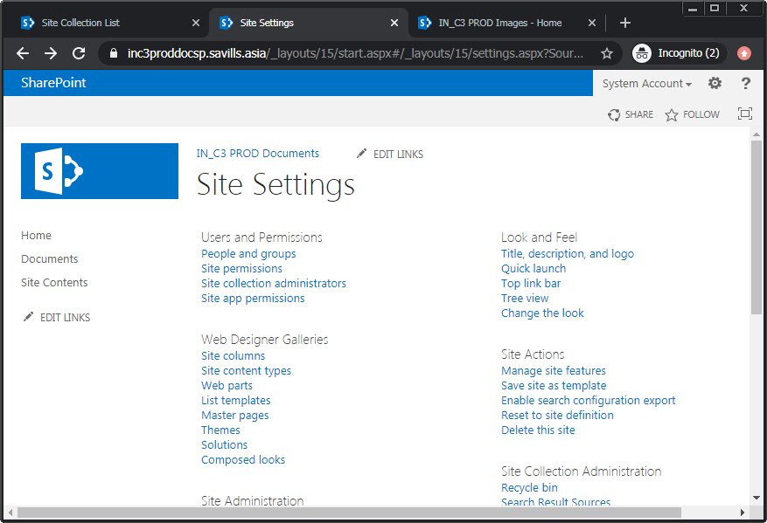
2. Invoke the “site permissions” command to bring up the permissions tab. From here, invoke the “grant permissions” menu command.
3. In the “share…” dialog, enter the keyword “reportinggroup” and allow searching to take place. From the retrieved list, locate the entry that has a GUID matching the ID of the AD organization unit originally selected to be used for the current Dynamics CRM instance, and select it. Then select “share.” The default permission level of “edit” is sufficient.  
   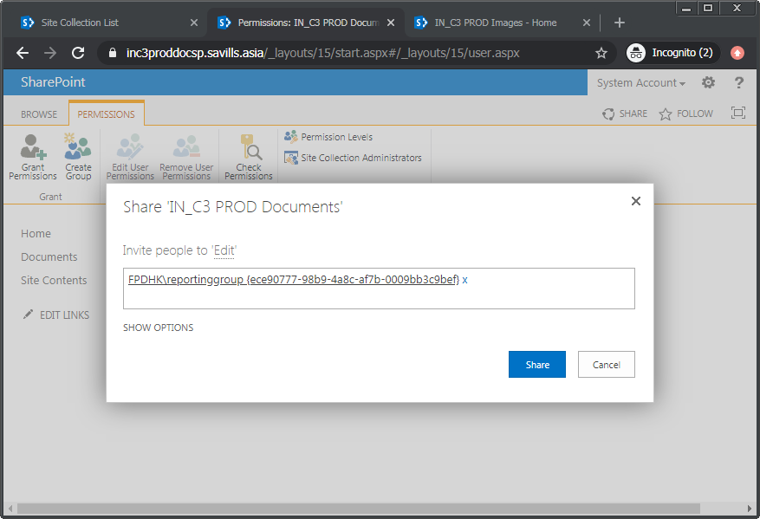
4.  Check the permissions list to verify that the reporting group has now been included.  
   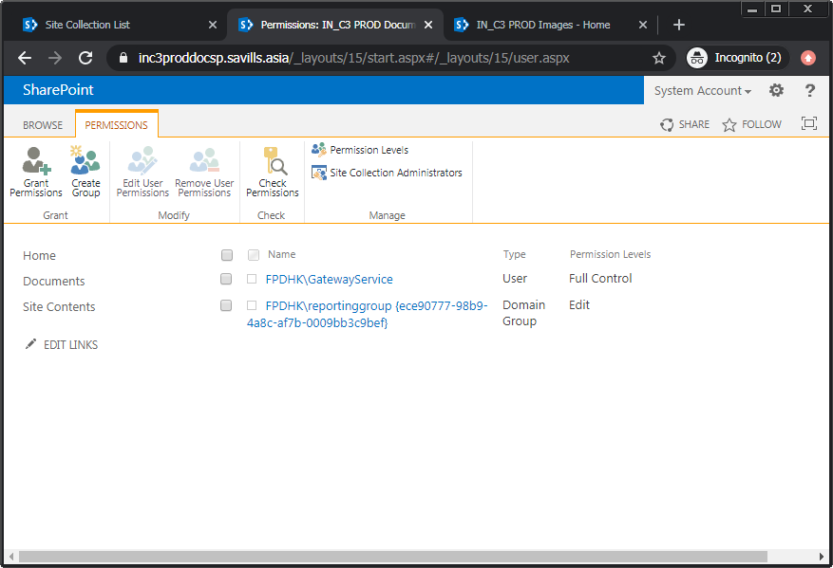

## Configure Document Site Collection

To configure the document site collection, carry out the following steps:

1. Navigate to the site’s home page. For the current example, the URL is “https://inc3proddocsp.savills.asia".  
   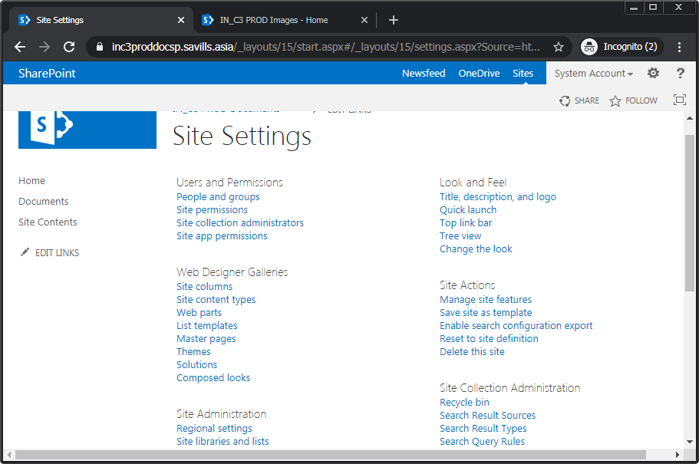
2. From the “Settings” menu, select the “Site Settings” option.
3. From the “Site Settings” page, open the “Solutions” option under the “Web Designer Galleries” section.
4. Invoke the “Upload Solution” menu command. From the “Add a document” dialog that comes up, use the “Choose File” control to select “crmlistcomponent.wsp” from the solution artifacts.   
   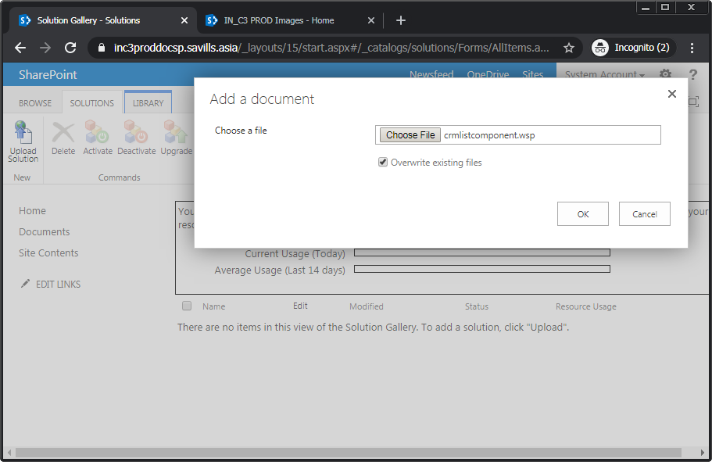
5. Directly invoke the “activate” command from within the upload completion dialog. Alternatively, back on the “Solutions” page, select the newly uploaded solution. Then invoke the “Activate” menu command.  
   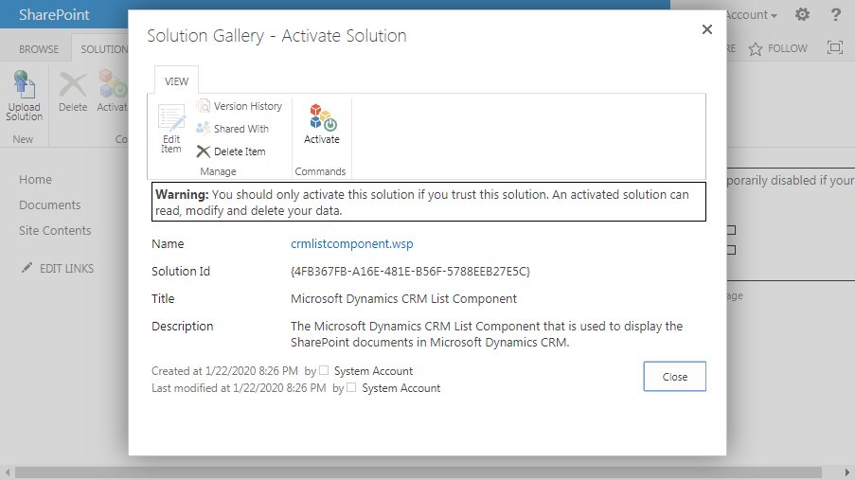
6.  Verify that the solution called “crmlistcomponent” has been added to the solutions list with the “solutions” panel. Further, ensure that its status is listed as “activated.”  
   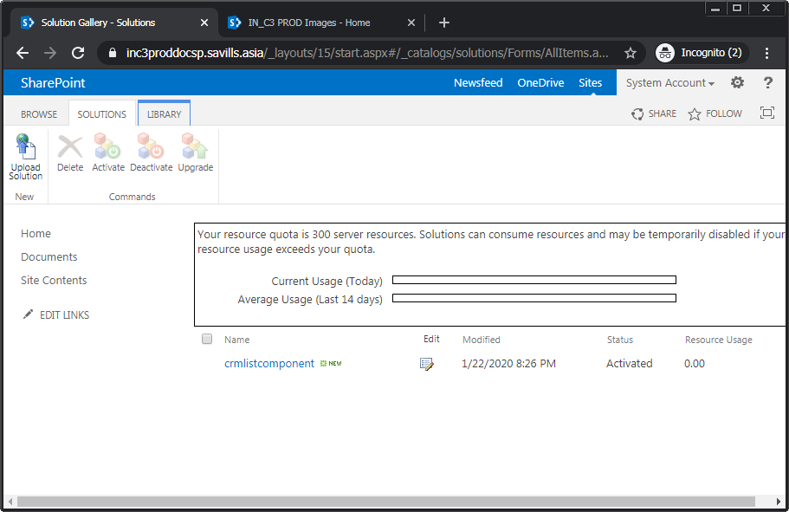
7. In the case that the “activate” menu command is disabled, this would indicate that the “Microsoft SharePoint Foundation Sandboxed Code Service” is not running. To address this, sign in to the SharePoint central administration site. From the main screen, invoke the “manage services on server” command under the “system settings” section. In the subsequently opened “services on server” page, look for the “Microsoft SharePoint Foundation Sandboxed Code Service” entry and select “start” for it.

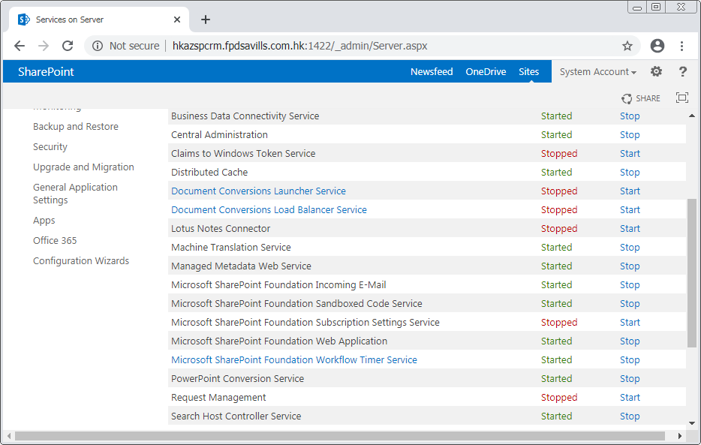  
 Verify that the status for this service has changed to “started” after this action.

## Configure Web Application and CRM Document Management Settings

Go through the following steps to configure the web application:

1. Sign in to the SharePoint central administration site. Use an administrative level account such as “FPDHK\GatewayService”.
2. From the main page, select “Manage web applications” under the “Application Management” section. On the subsequently shown “web applications” tab, note down the URL for the entry named “Default Web Site” in this example. In this example, the URL is <http://hkazspcrm.fpdsavills.com.hk:1422>.  
   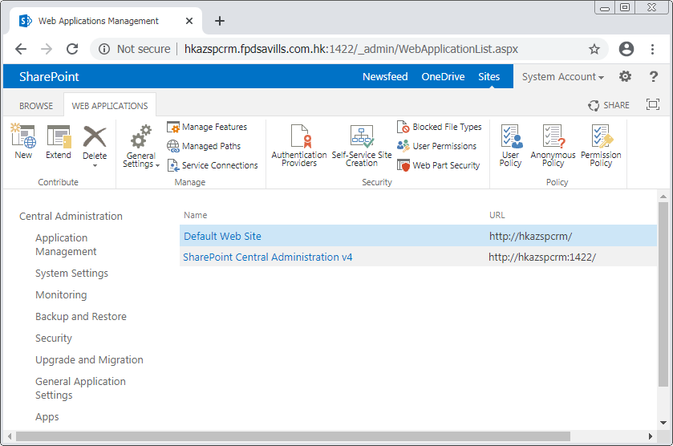
3. Copy the “AllowHtcExtn.ps1” script to the SharePoint server. In this example, the server is “hkazspcrm.fpdsavills.com.hk.”
4. Then, run “AllowHtcExtn.ps1” on the SharePoint server using the URL retrieved earlier as argument. For example,   
   ./AllowHtcExtn.ps1 http://hkazspcrm/  
   Administrative rights may be needed.   
    Check for response text indicating success before proceeding.

Now, configure Dynamics CRM’s document management settings:

1. Log in to Dynamics CRM by browser, using an account that has “System Administrator” level access.
2. From the “settings” menu section, under the “system” sub-section,” select the “document management” option. From the resulting page, open “Document Management Settings.”  
   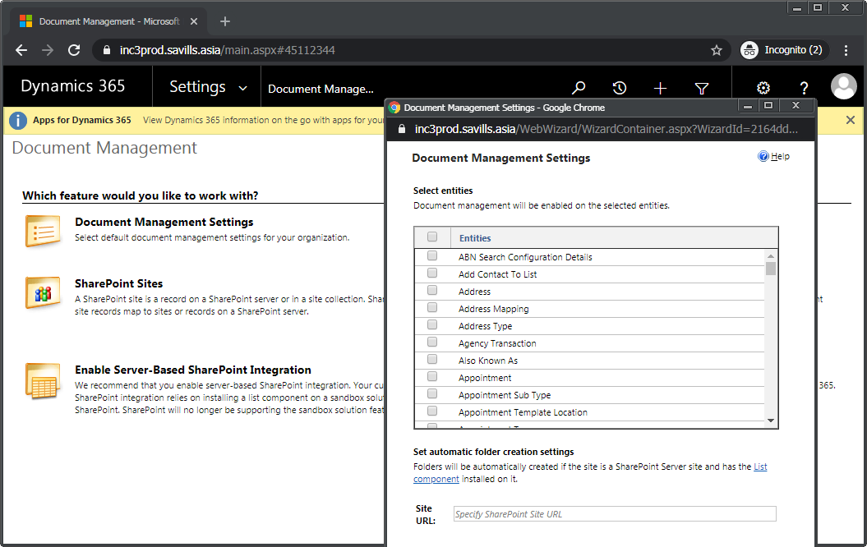
3. The following entities and only these should already be selected in the opened dialog:
   * Appointment/Job
   * Available Property
   * Campaign Site
   * Opportunity
   * Property Address
   * Property Marketing Information
   * Valuation Job

Check to ensure that this is the case. Otherwise, make the required selections until this is the case.

1. Finally, for the “Document Site Url” field, entered the URL for the newly created SharePoint document site. In our example, this would be “https://inc3proddocsp.savills.asia”. During the first time this is done, a sign-in is required. Use the designated installation account such as “FPDHK\GatewayService”.  
   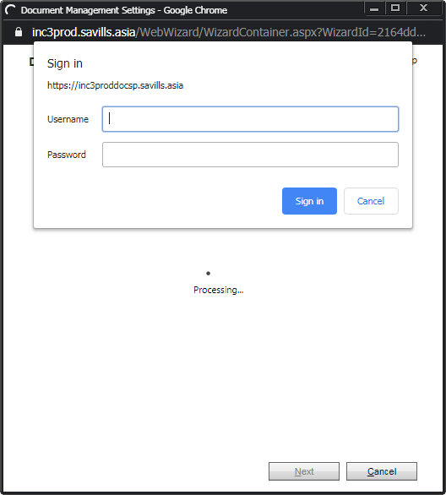
2. In the subsequent steps, leave the default values and click through.  
   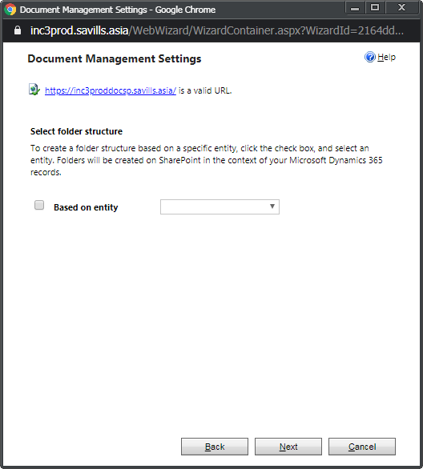 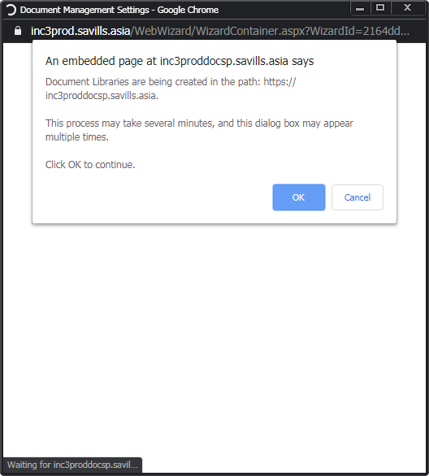
3.  Finally, confirm success by reviewing the confirmation dialog and choose “finish.” It should be similar to the following illustration.  
   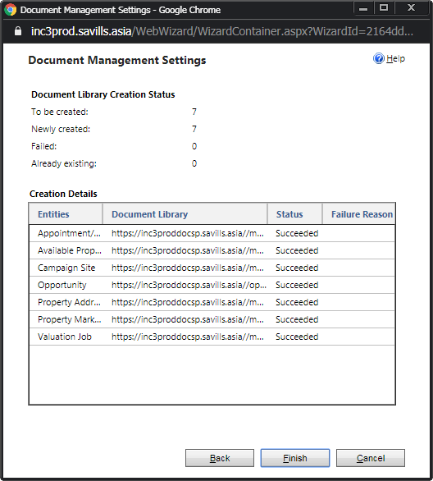

## Configure Image Site Collection

Configure the SharePoint image site collection as follows.

1. Visit the image collection site created earlier by entering its main URL in a browser. In the example, the URL is “https://inc3prodimgsp.savills.asia”.
2. From the site’s main page, open the “site contents” page. Invoke the “add an app” command, and subsequently choose “picture library.”

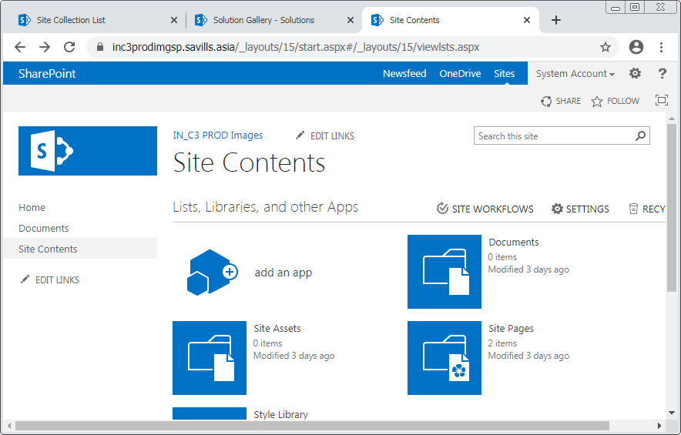  
  
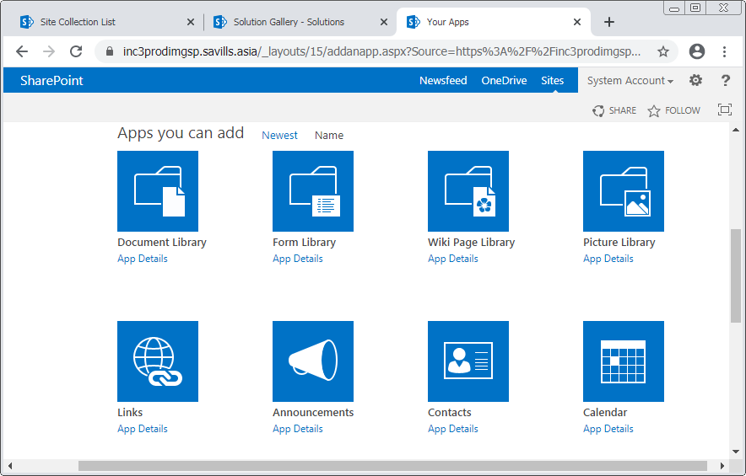  
Give the name of “Property Address” in the creation dialog of “adding picture library,” and then choose “create.”  
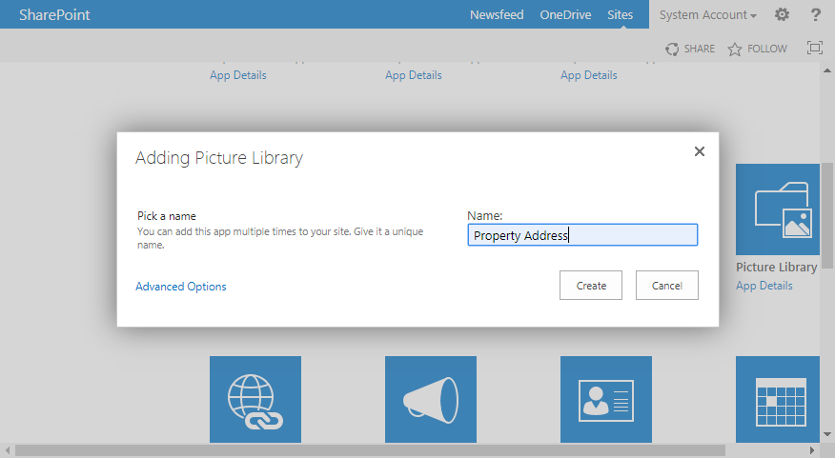

1. Similarly, create four more “picture library” apps, with the names of:
   * Master Listing
   * Basic Listing
   * Feature Images
   * Logos

The contents should look similar to this when this is completed, where there are now five new picture libraries.  
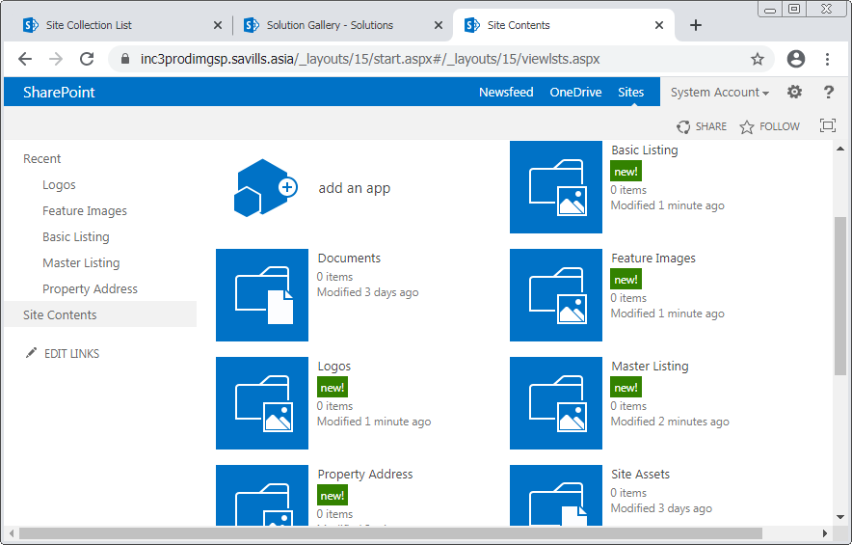

1. Open the “Feature Images” app folder. Then using File Explorer, browse locally to the “Feature Images” folder with the installation artifacts. Select all the image files within this folder, and drag and drop these onto the opened “Feature Images” app in the browser.

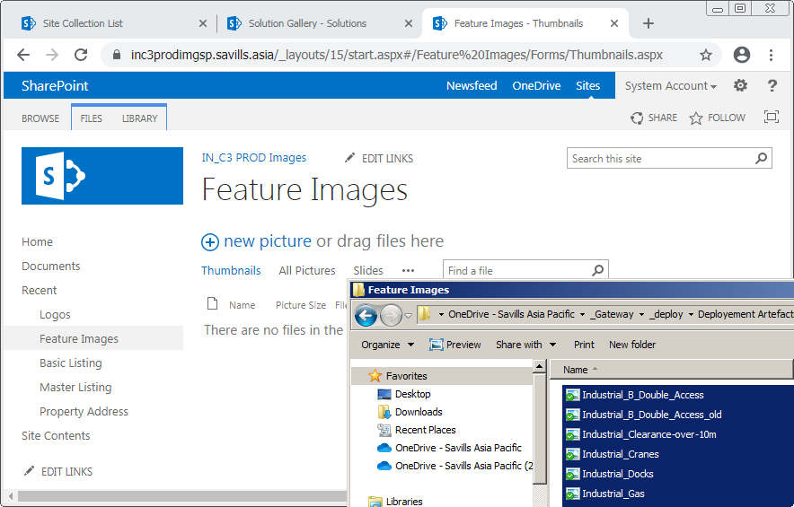   
 These should display when the transfer is completed.  
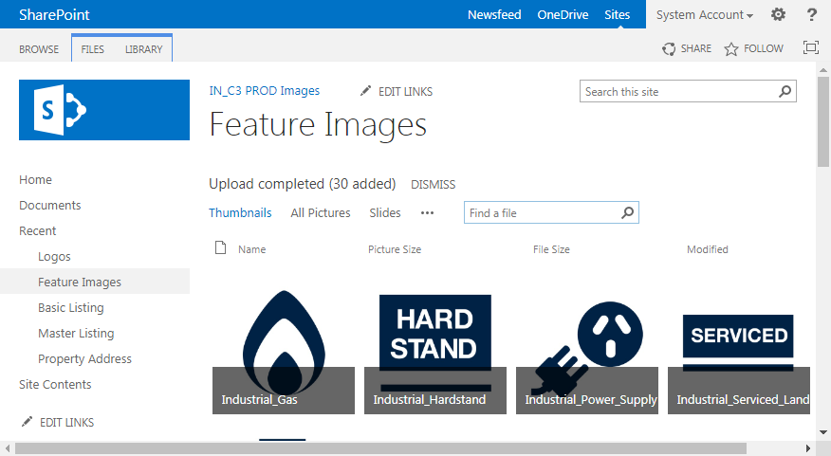

1. Similarly, open the “Logos” app folder. Then using File Explorer, browse locally to the “Logos” folder with the installation artifacts. Select all the image files within this folder, and drag and drop these onto the opened “Logos” app in the browser.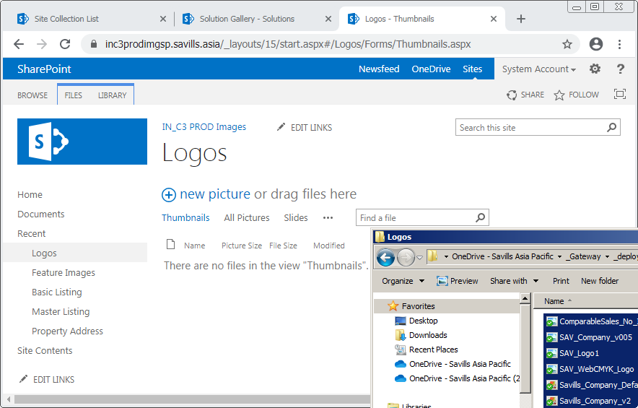   
    These should also display when the transfer is completed.

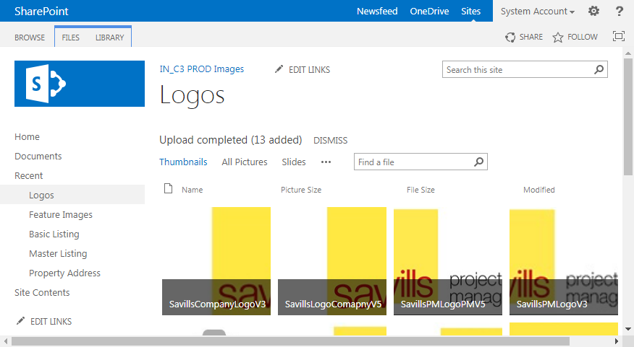

## Add Permissive X-FRAME-OPTIONS Header Feature

This feature allows SharePoint pages to be embedded inside an iFrame in Dynamics CRM. For example, the “Image Library” page of a property entity in CommercialCube uses an iFrame to display the corresponding SharePoint site.

Note that this step has to be performed only once for a single Dynamics CRM instance. When adding an additional organization, this section can be skipped. However, the last step of verification in these steps can be performed as a health check.

Follow these steps to add this feature:

1. Using a “Farm Admin” level SharePoint account, such as “GatewayService,” copy the file “Ventigrate.Shared.PermissiveXFrameHeader.zip” from the installation artifacts to the SharePoint server.  
   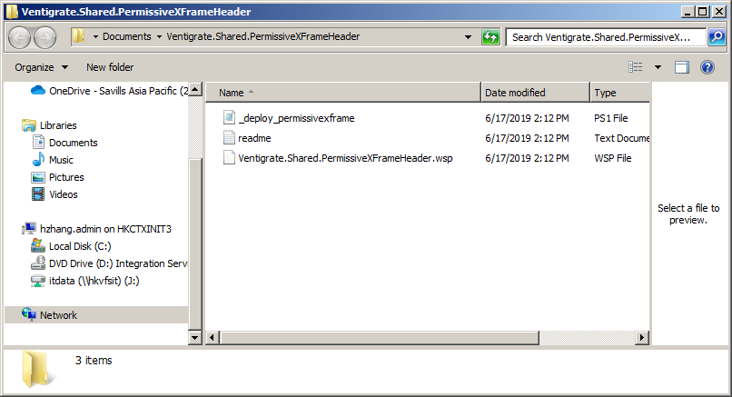
2. Unzip this file.
3. Locate the Powershell script “_deploy_permissivexframe.ps1” in the unzipped contents and run it. Check the output to ensure that the script ran successfully.  
   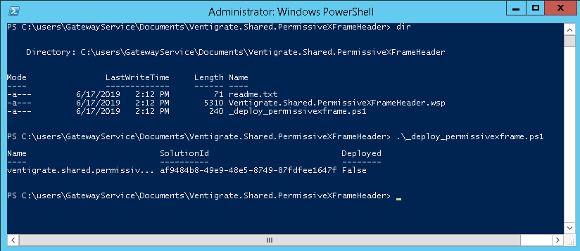
4. Visit the SharePoint Central Administration site. From the home screen, within the “Application Management” section, select “Manage Web Applications.”  
   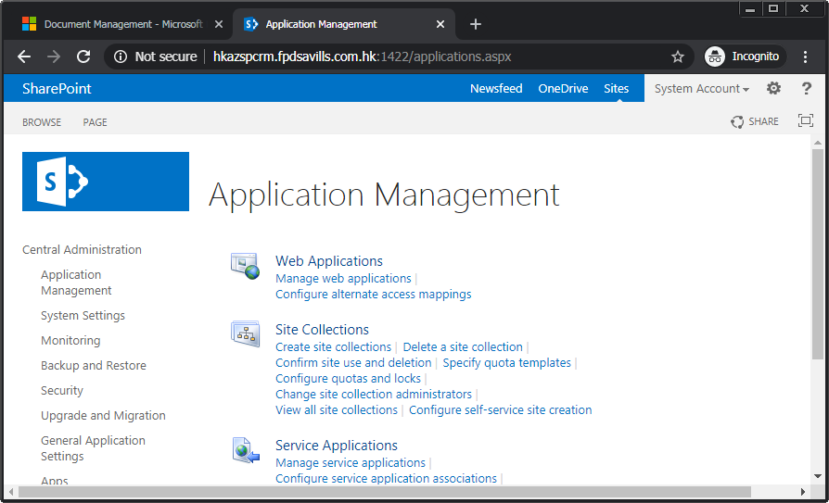
5. Then, select the appropriate web application entry, if it is not already highlighted. For this example, it is the “default web site” entry. Then, invoke “Manage Features” action.   
   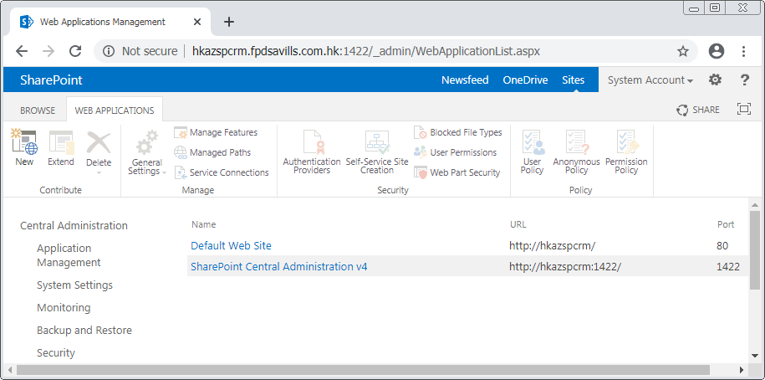
6. Locate the “Permissive X-FRAME-OPTIONS Header” entry from the list shown in the “manage web application features” dialog and invoke the “Activate” command for it.   
   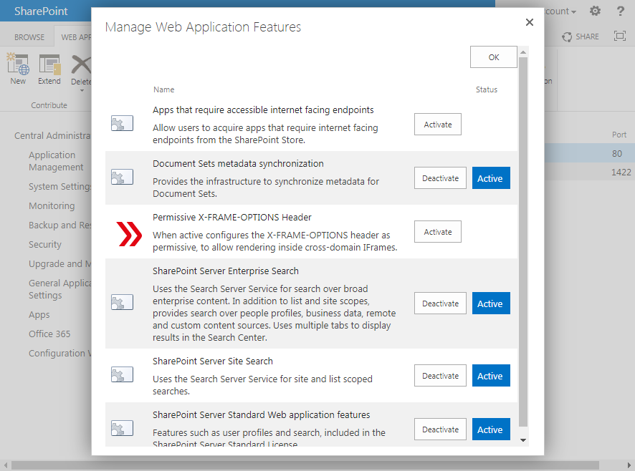
7.  Verify that the “Active” indicator label is now shown for this entry.  
   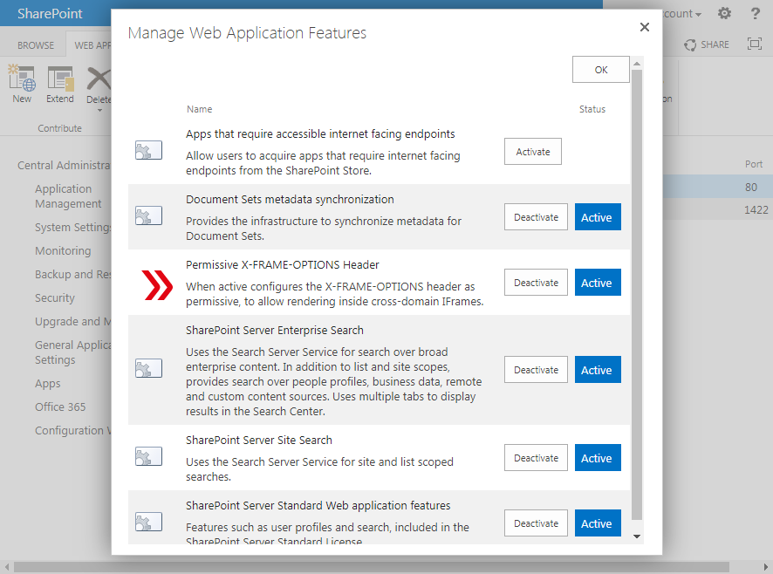

# Setup Image Portal

This section covers the creation of the image portal web application.

Set up the image portal website as follows.

1. Locate “ImagePortalDeployment.zip” from within the installation artifacts, and copy this file to the location “c:/inetpub” on the web application tier server.
2. Unzip the file to its current location.
3. Rename the folder to associate it with the country and implementation phase being targeted for this installation. For example, prefix the folder name with a country code and a phase name, as in “InProdmagePortal” or “TwProdImagePortal.”  
   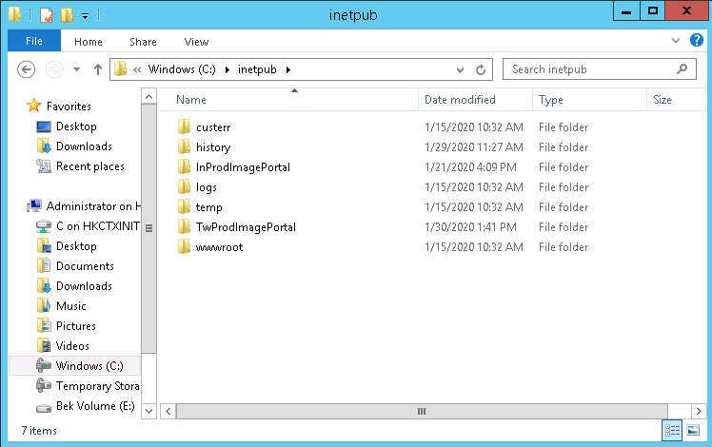
4. At this point, add the user “FPDHK\C3ImagePortalService” to Dynamics CRM by going through the go the “settings” menu section, then the “security” sub-section and then “users” option. For specific steps of adding a new user, refer to “appendix: add organization.” Then for this user, use the “manage roles” menu command to assign it “system administrator” rights.  
   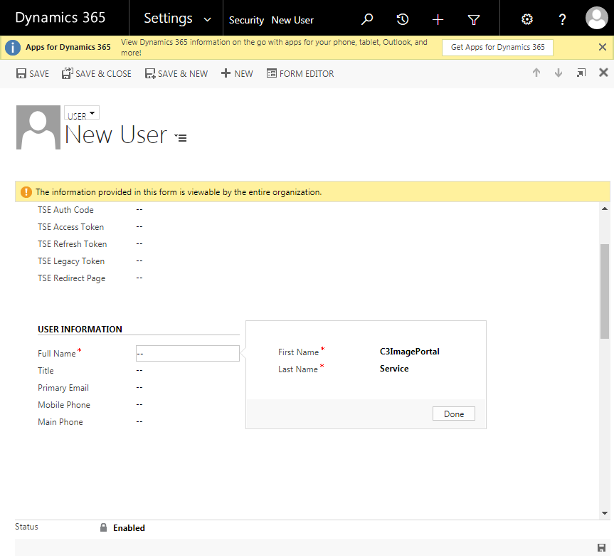 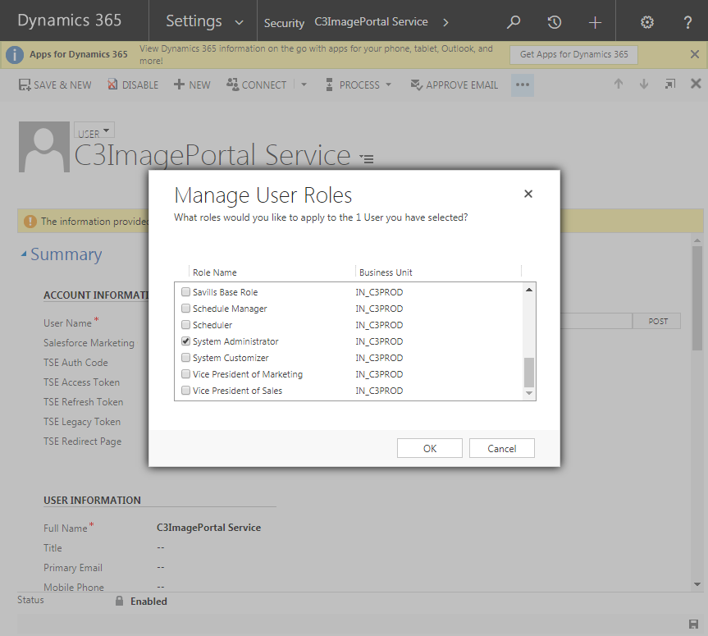
5. Use Notepad to update the XRM connection string within the file “web.config” to use the above added user’s credentials. Note that claims-based authentication, that is, “IFD”, should be used for the authentication type. For example,

<add name="XRM" connectionString="Url=https://inc3prod.savills.asia/inc3prod; Domain=fpdsavills.com.hk; Username=fpdsavills.com.hk\C3ImagePortalService; Password=; AuthType=IFD" />

1. Use Internet Information Services (IIS) Manager to create a new site with the above created folder as its physical path. Use HTTPS binding and select the “*.savills.asia” wildcard certificate as SSL certificate. Choose a host name that reflects the country being targeted. For example, “inc3prodimgupload.savills.asia.”  
   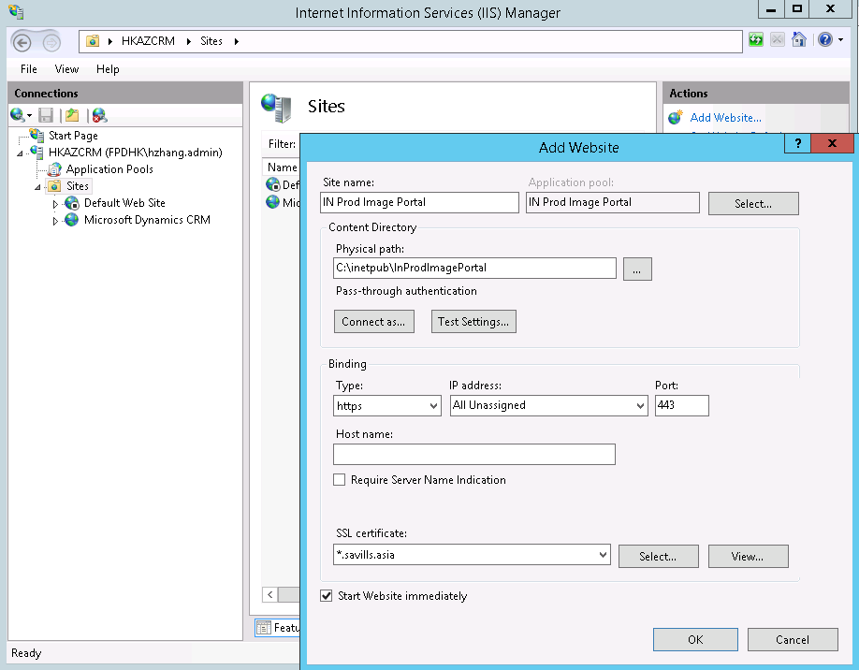   
      
   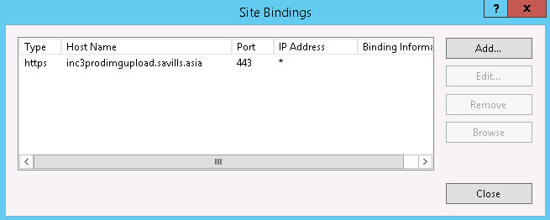
2.  Provide the chosen host name to the infrastructure team, in order to add a DNS entry to the web application tier server. Proceed after the entry has been added. Note

For Example



1.  Verify that the site is created properly by visiting it in a browser. The site should present a blank page without any error or warnings. Further, the status code from within an F12 developer panel from within the browser should indicate a “200” or similar value as the response.

# Update CRM Configuration Settings

This section covers initialization of the configuration values for CommercialCube.

Go to the Dynamics CRM site by browser. Open the “configurations” page by going to the “settings” menu section, then under the “system” sub-section, selecting “configurations.”

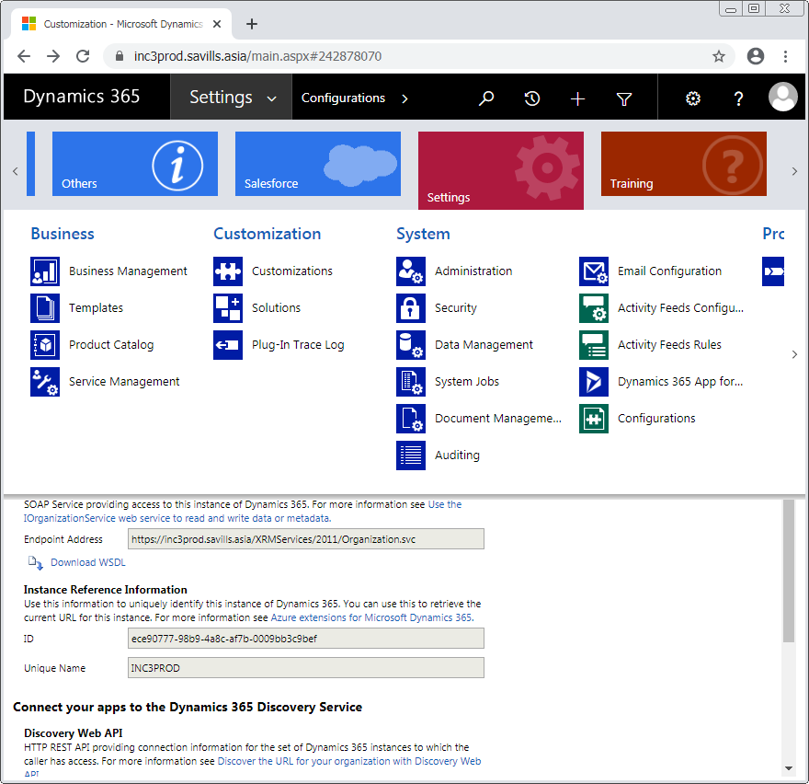

## CRM Organization ID Setting

To update the value for configuration setting “CRMOrganizationID,” use the value of the CRM’s organization ID. This can be obtained by accessing the “settings” menu section, and then under the “customization” sub-section, select the “customizations” option. From the “customization” main page, select the “developer resources” option, and then from this resulting page, look under “Instance Reference Information” and then note down the value of the “ID” field.  
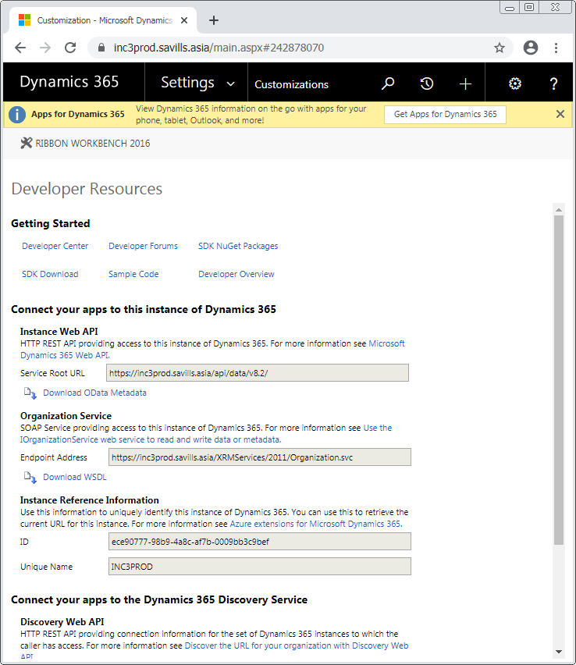

## Image Portal URL Setting

Update the value for the configuration setting of “ImagePortalUrl,” which is the URL for the image portal. One such image portal is setup, as described earlier in this procedure, per country. For this example, it has the value “https://inc3prodimgupload.savills.asia/”.

## Report Server Settings

Update the following report server settings:

1. Update the value for the configuration setting of “ReportExecutionServiceUrl,” which normally takes the form of   
   http://<SSRSServerName>/ReportServer/ReportExecution2005.asmx  
   , where <SSRSServerName> is “hkazspcrm.fpdsavills.com.hk:1422” in this example.
2. Update the value for the configuration setting of “ReportServiceUrl,” which normally takes the form of   
   http://<SSRSServerName>/ReportServer/ReportService2005.asmx  
   , where <SSRSServerName> is “hkazspcrm.fpdsavills.com.hk:1422” in this example.
3. Update the value for the configuration setting of “ReportUserDomain” to be the domain name of the report server’s administrative user. For this example, it is “fpdsavills.com.hk”.
4. Update the value for the configuration setting of “ReportUsername” to be the user name of the report server’s administrative user. For this example, it is “GatewayService”.
5. Update the value for the configuration setting of “ReportUserPassword” to be the password of the report server’s administrative user.

## SharePoint Settings

Update the following SharePoint settings:

1. Update the value for the configuration setting of “SharePointDocumentSiteUrl” to be the URL of the SharePoint document site set up earlier. For this example, it is https://inc3proddocsp.savills.asia
2. Update the value of the configuration setting of “SharePointImageSiteUrl” to be the URL of the SharePoint document site set up earlier. For this example, it is https://inc3prodimgsp.savills.asia
3. Update the value of the configuration setting of “SharePointDomain” to be the domain name of the SharePoint administrative user. For this example, it is “fpdsavills.com.hk”.
4. Update the value of the configuration setting of “SharePointUsername” to be the user name of the SharePoint administrative user. For this example, it is “GatewayService”.
5. Update the value of the configuration setting of “SharePointPassword” to be the password of the SharePoint administrative user.

## Admin User Setting

Update the value of the configuration setting of “Admin User” to be the full domain account name of the administrative user. For this example, it is “fpdsavills.com.hk\ GatewayService”.

# Configure Dynamics CRM for Using FetchXML Reports

This section covers the necessary configuration procedure to be taken for Dynamics CRM to be able to run FetchXML reports. This section is to be skipped when adding an organization for a country, as the steps only need to carried out once when installing an instance of Dynamics CRM.

## Set Service Principal Names for Service Account

To set the service principal names (SPN) for the service account used to run the Dynamics CRM application pool, follow these steps:

1.  Using an account with sufficient privileges, such as “FPDHK\Administrator”, open a command prompt as an “administration” on any client on the same network as the web application tier server.
2. Run the command of “setspn -s HTTP/<server name> <full account name>”. Specifically, the service account in question is the “FPDHK\GatewayService” account. In this example, the command is:  
   setspn -s HTTP/HKAZCRM FPDHK\GatewayService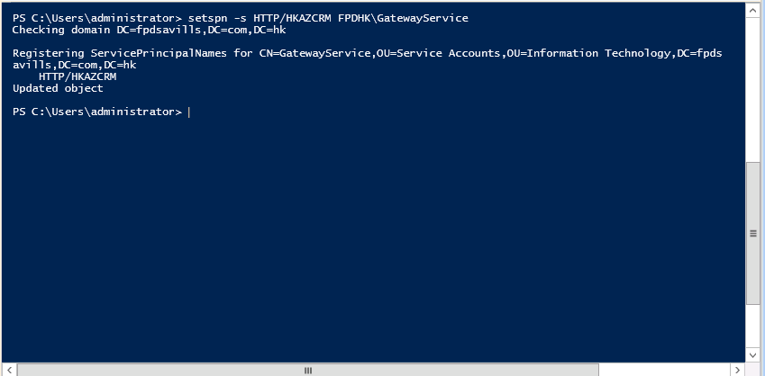
3. Next, run the command of “setspn -s HTTP\<server’s fully qualified domain name> <full account name>”. In this example, the command is:

setspn -s HTTP/HKAZCRM.fpdsavills.com.hk FPDHK\GatewayService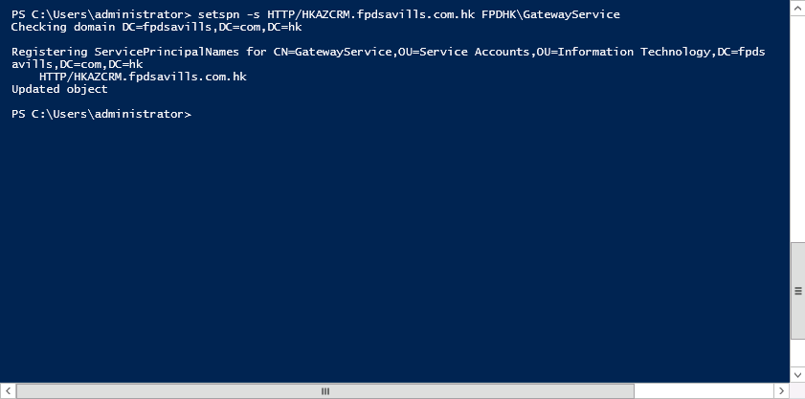

1.  To verify that the SPNs have been added, use the command “setspn -l <full account name>”. In this example, the command is:  
   setspn -l FPDHK\GatewayService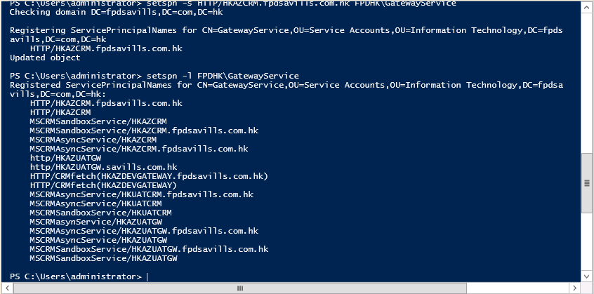

## Edit Configuration for Dynamics CRM Website

The Dynamics CRM website needs to have its configuration value for “useAppPoolCredentials” set to “true” as well. To achieve this, use the following steps:

1. On the web application tier server, start Internet Information Services (IIS) Manager.
2. Locate the “Microsoft Dynamics CRM” site. Within its “feature view,” under the “management” section, select the “configuration editor” option.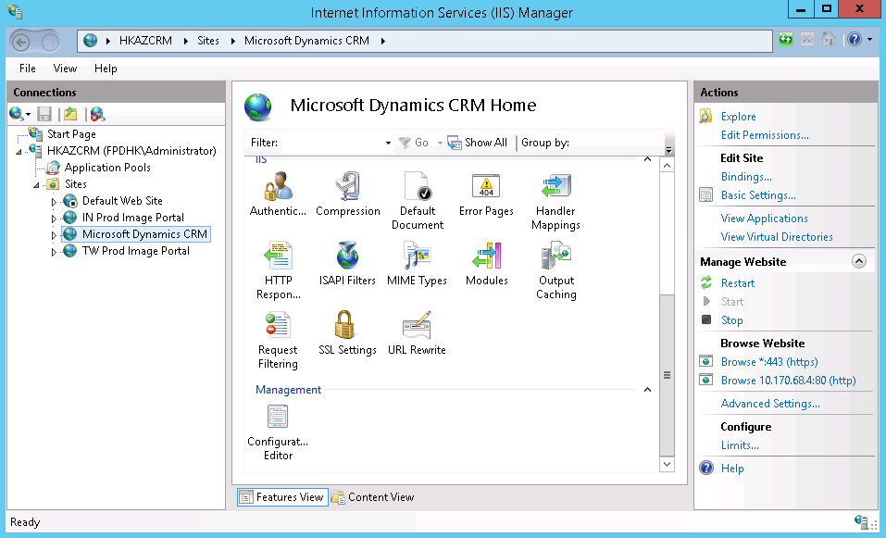
3. In the “configuration editor,” locate the “from” drop-down selection control. Select the “application.config <location …” option.
4. Next, locate the “section” drop-down selection control. Expand the “system.webserver” node, then the “security” node, then the “authentication” node, and finally select the “windowsAuthentication” entry.

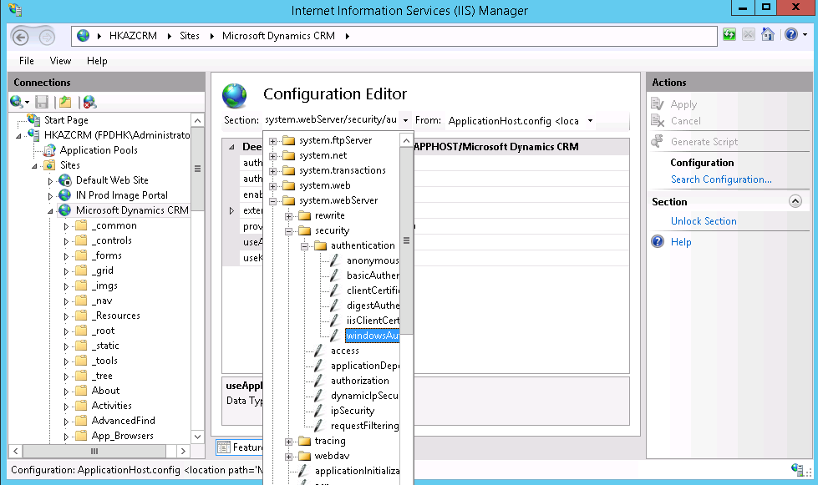

1. In the subsequent properties form, set the property of “useAppPoolCredentials” to the value of “true.” Then invoke the “apply” action for this change to take effect.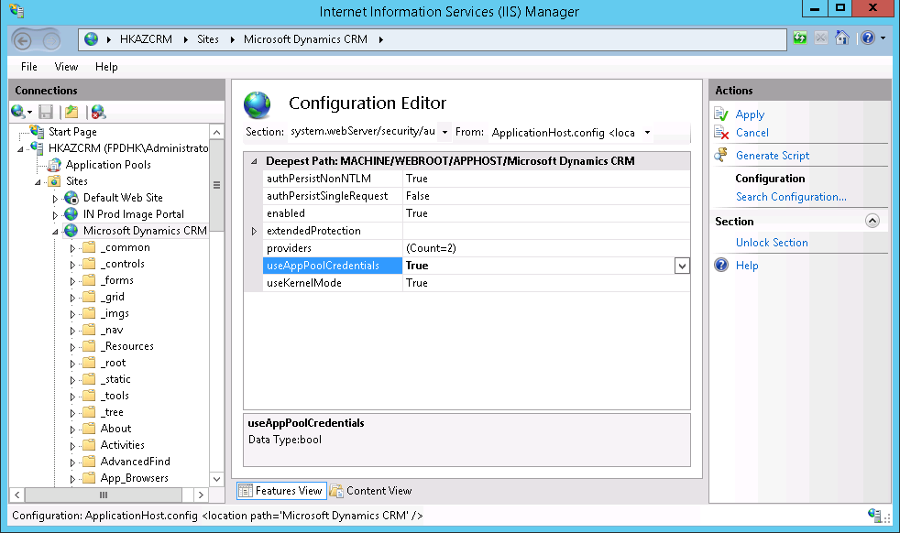

## Verify FetchXML Reports Can be Run

To verify that FetchXML reports can indeed be run from Dynamics CRM at this point, use the following steps:

1. From within Dynamics CRM, go to the “settings” menu section, under the “others” sub-section, select the “reports” option.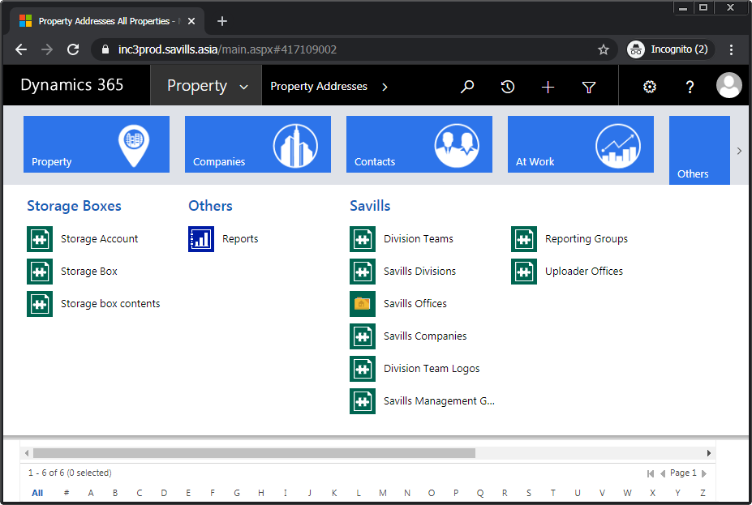
2. Invoke the “new” menu command to bring up the “new report” dialog. Select the “run wizard” action on the shown dialog.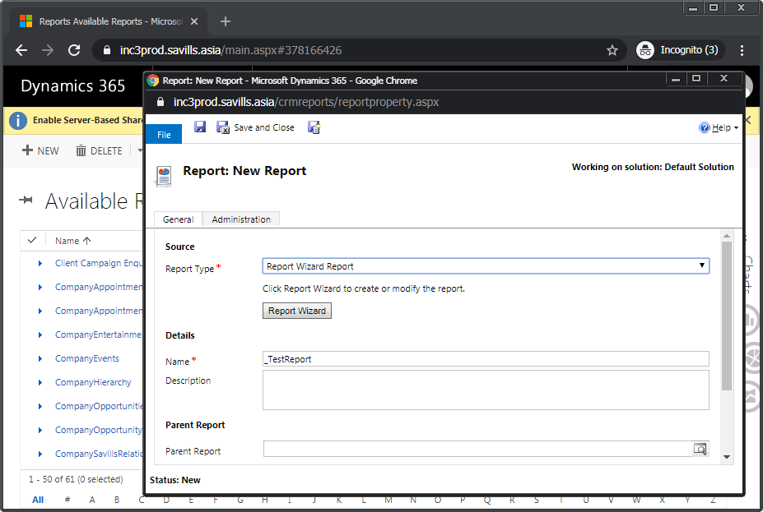
3. Select the “start a new report” option.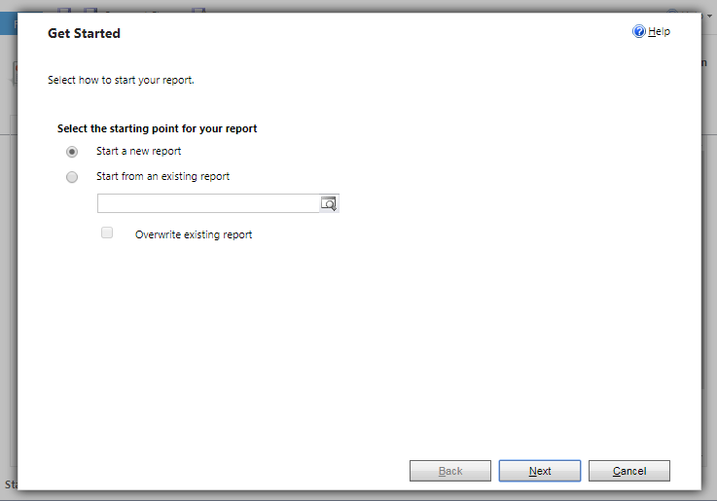
4. Give the “report name” a value, for example, “_TestReport”. Select a primary record type, for example, “property addresses.” Select “next” and then “next” again for the following page.  
   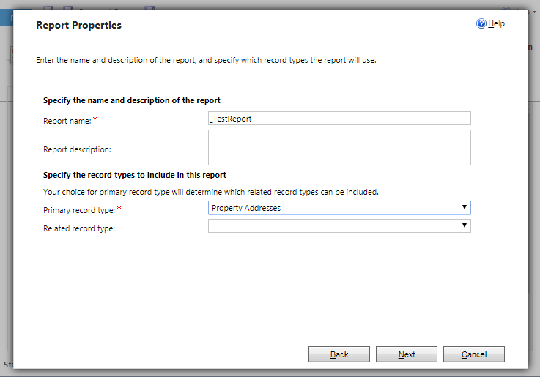
5. Next, on the “lay out fields” page, select the “click here to add a column” action. Leave the defaults in the “add column” form and choose “ok.” Then, select “next.” 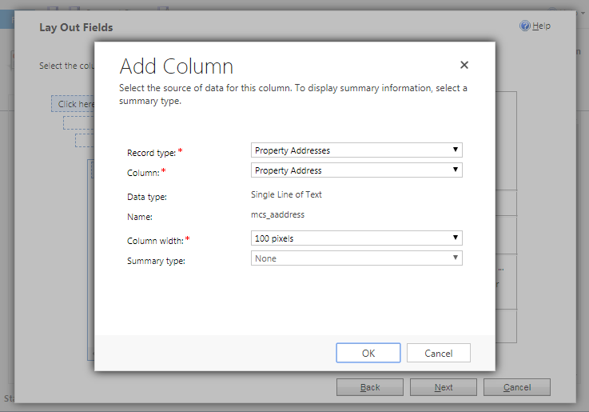
6. Click through and accept the defaults for the remaining pages of the wizard.  
   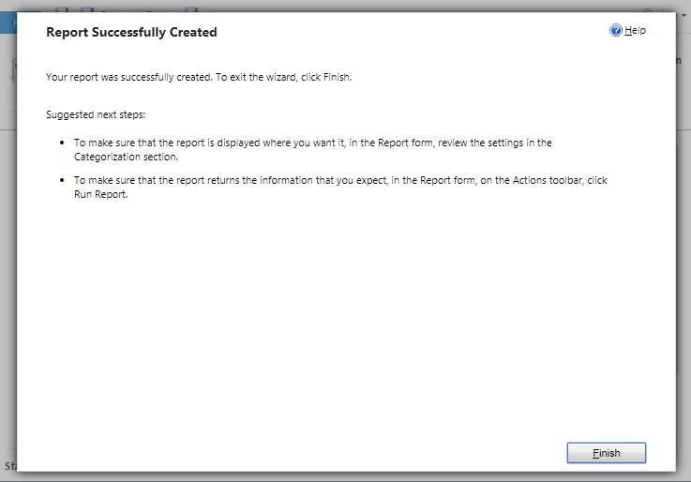
7. Back on the report’s main page, choose the “run report” action, which is now available.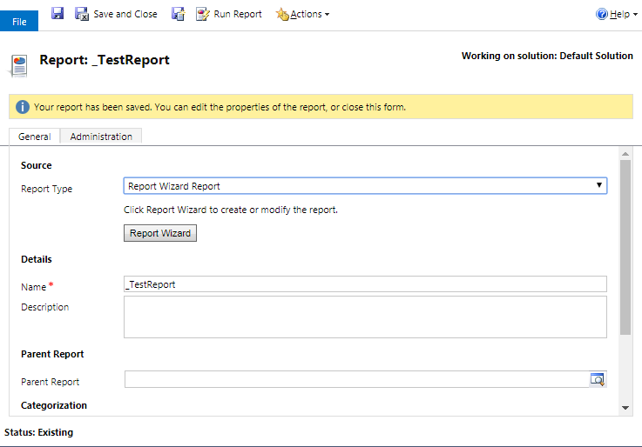
8.  Verify that the report is properly generated with title and formatted content, and that no error messages are showing.  
   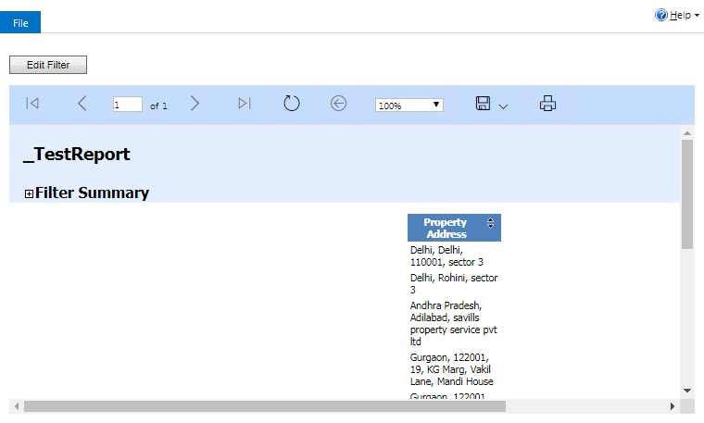

# Verifying Integration

This section covers the post-deployment steps that can be taken to verify the integrations between the various, constituent components of CommercialCube have been setup properly.

To verify that the three tiers and their contained components

* Web application tier
  + CRM component
  + Image portal component
* Data tier
  + Database component
  + Reporting component
* File Storage tier
  + SharePoint component

are correctly integrated, the following procedures can be used.

## Verify CRM component to database component integration

Completion of the Dynamics CRM installer should already indicate a proper level of integration between the CRM and database components . These steps confirm this at a usage level. As well, the result of this are needed for the subsequent verification procedures.

1. Sign-in to Dynamics CRM with an account that has the “system administrator” role.
2. Navigate to the “properties” menu section and select “property addresses.” Then, select the “all properties” panel if it is not already selected.
3. Invoke the “new” menu command to create a new property.
4. Save the property. If this is successful, the CRM component is integrated properly with the database component.

## Verify CRM component and SharePoint component integration

1. Open the newly created property. From the main menu section for this property, select the “documents” option.
2. If this is the first time accessing the document library, credentials need to be entered as well. Also, agree to the prompt about folder creation.  
   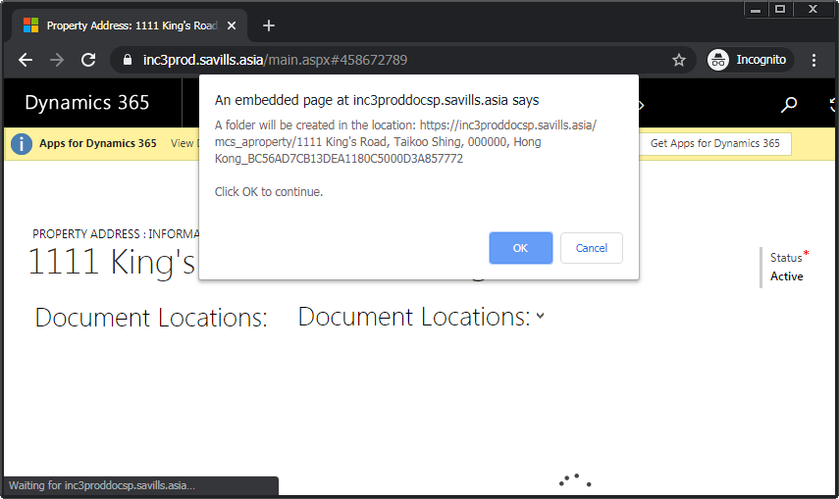
3. When the documents panel comes up, an empty documents list is shown.
4. Invoke the “add” menu command to bring up the “add documents” dialog. From here, use the “choose file” control to select a local document, such as a Word document in this example.  
   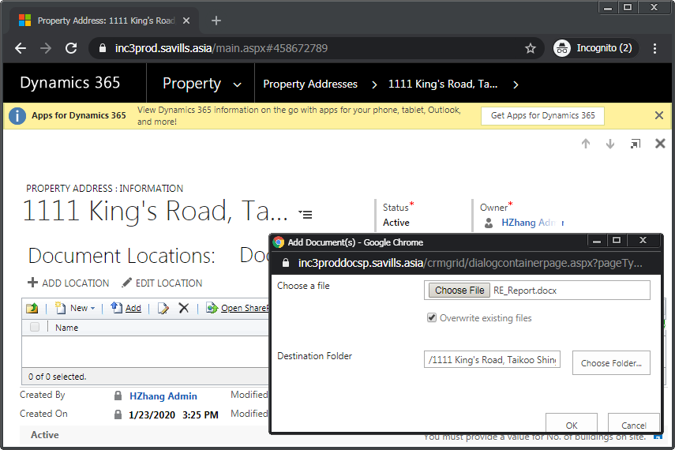
5. Once the document is added, use the “refresh” control in the list’s sub-menu to update the documents list. Verify that the document is now showing. This confirms that the CRM component is correctly integrated with the SharePoint component.  
   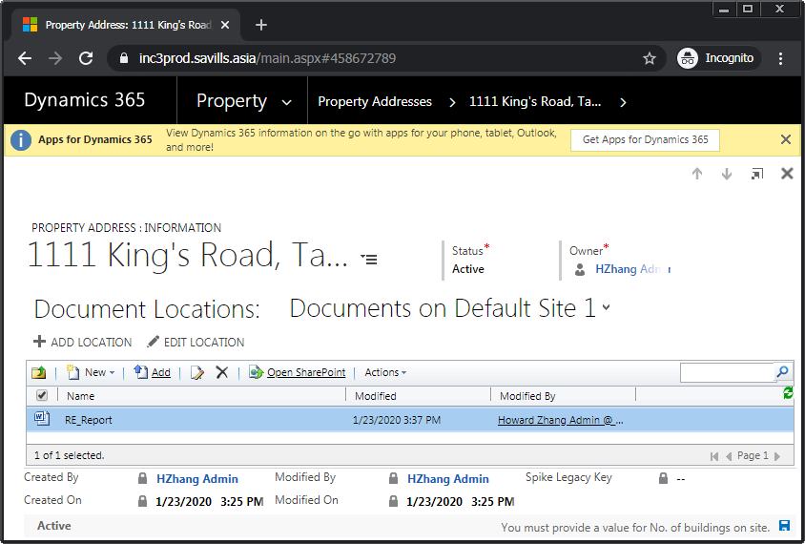

## Verify CRM component to image portal component integration

1. Again open the newly created property. From the main menu section for this property, select the “image library” option.
2. If this is the first time accessing the image library, credentials need to be entered as well.
3. When the image library panel comes up, no images are yet available.
4. Drag and drop one or more images from local storage onto the designated area labeled “new picture or drag files here.” Thumbnails of the images should show immediately.  
   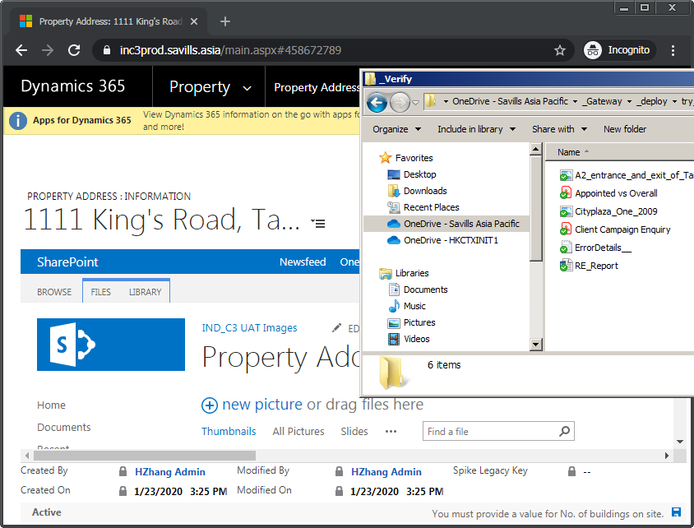
5. Navigate back to the property’s page. Select the “select hero image” control.
6. From the subsequently shown dialog, the previous added image(s) should be available for selection. Choose one of the images by selecting the “hero image” action control below that image. Close the dialog.  
   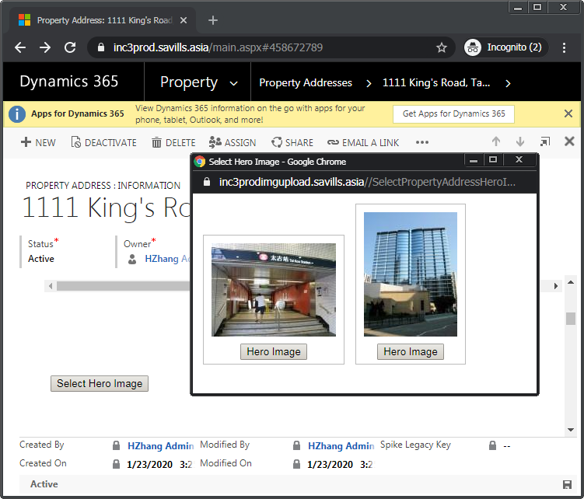
7. Verify that the property’s page is now showing the selected image as a thumbnail in the space designated for its hero image. This confirms that the CRM component is correctly integrated with the image portal component.  
   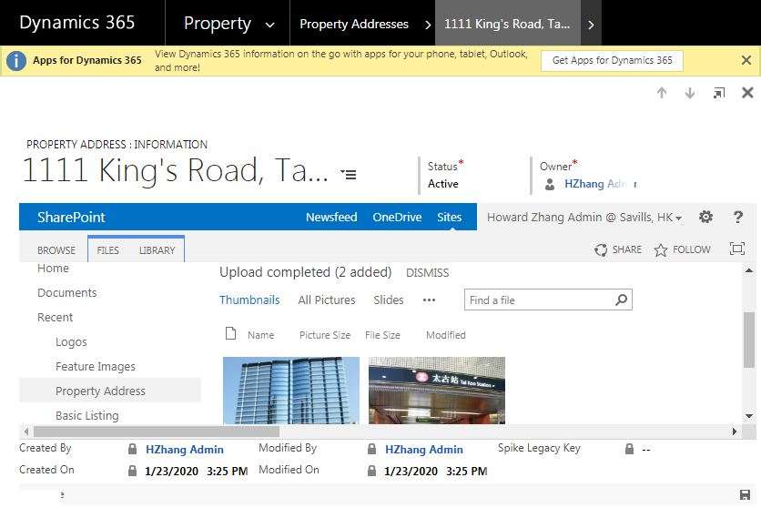

## Verify CRM component to reporting component integration

To verify the integration between the CRM and reporting components, generate a couple of reports from the CRM as follows:

1. Go to the “property” menu section, then select the “property addresses” menu item to open the “all properties” page.
2. Invoke the “run report” menu command, and select the “appointed vs. overall” sub-menu item.
3. Verify that the generated reported shown in the pop-up contains logo(s), formatted text, coloring and positional formatting. Optionally save this report as a PDF using the “save” action.

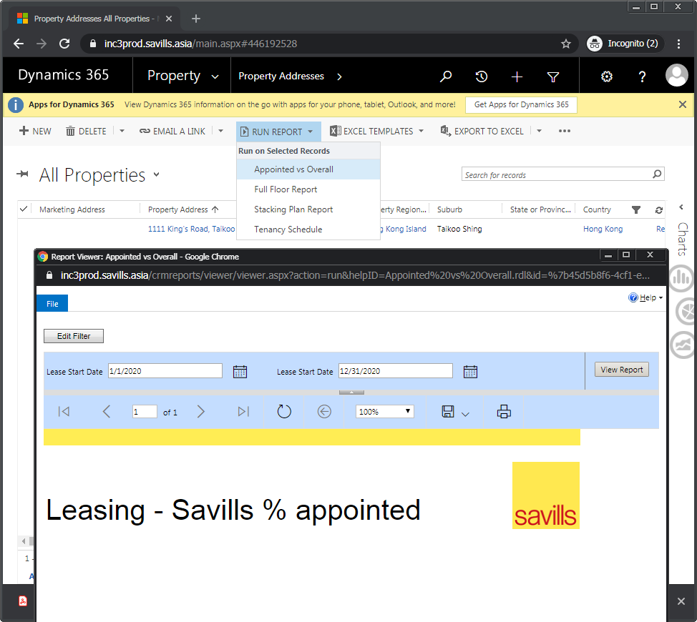

1. Go to the “contacts” menu section, then select the “contacts” menu item to open the “active contacts” page.
2. Invoke the “run report” menu command, and select the “weekly report” sub-menu item.
3. Verify that the generated reported shown in the pop-up contains logo(s), formatted text, coloring and positional formatting. Optionally save this report as a PDF using the “save” action.  
   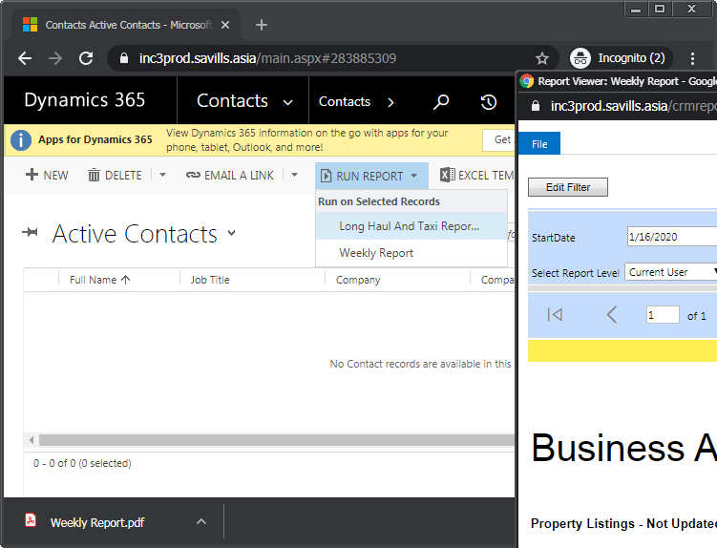  
   This confirms that the SharePoint component has been properly integrated with the CRM component.

# Appendix: Add Organization

This appendix covers the process for hosting additional countries in the same Dynamics CRM instance by means of creating additional organizations.

The same Dynamics CRM instance can serve multiple countries by way of hosting separate organizations. To add a new organization to an already existing Dynamics CRM installation, follow these steps:

1. Sign in to the web application tier server. For this purpose, use an account that also has been granted “Deployment Administrator” access in “Dynamics 365 Deployment Manager.”
2. Launch the “Dynamics 365 Deployment Manager” application. The “development” instance of Dynamics CRM is shown here, for example.

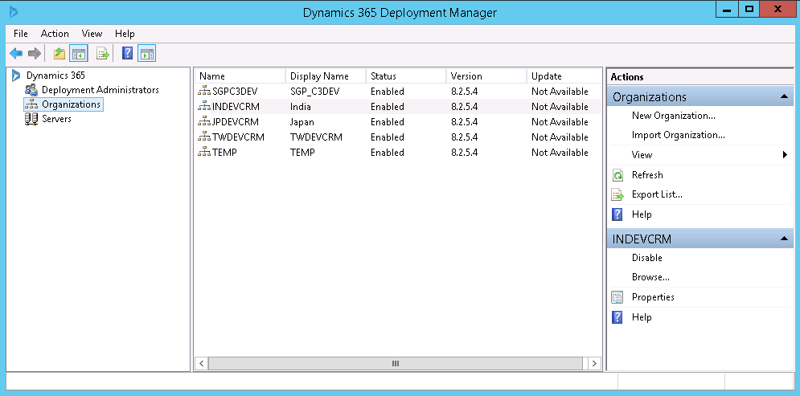

1. From the explorer panel, locate the “Organizations” node under the main “Dynamics 365” node. From its context menu, select the “new organization” menu command to start the “new organization wizard.”
2. Fill in the “display name” entry using a meaningful name that indicates both the country being targeted and the delivery phase. In this example, the display name value uses “IDN” as a prefix to indicate Indonesia, and a postfix of “DEV” to indicate development environment.  
   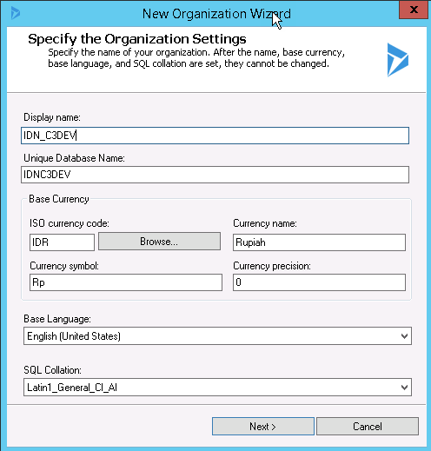
3. The “unique database name” is automatically filled in. This provided value is generally acceptable.
4. With the “browse” command under the “ISO currency code” setting, select the appropriate currency for the new organization being created. In this example, the currency chosen is IDR, which is the Indonesian Rupiah. The remaining values are filled in with their corresponding defaults.
5. Leave the rest of the values as-is, and continue by selecting “next.”
6. For the subsequent step of specifying “select SQL server,” provide the same one as used for the Dynamics CRM instance. In this example, it is “HKAZDEVSQL1\DEVSQL1.”
7. Then, for the subsequent step of “specify reporting services server,” provide the same one as used for the Dynamics CRM instance. In this example, it is “http://hkazdevsql1/ReportServer.”
8. Ensure verification results are acceptable for the “system checks” step.

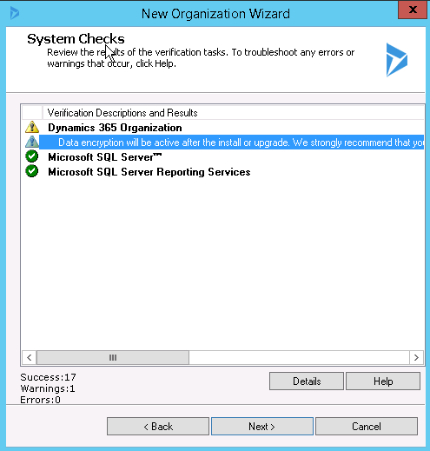

1. Complete the process by selecting “finish” in the last step.  
   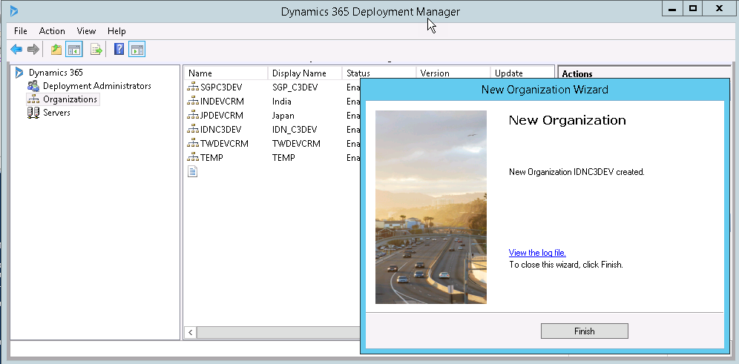
2.  Verify that in the list of organizations, the newly created one now exists.

# Appendix: Add New User

This appendix covers the process for adding new users to a CommercialCube deployment.

To add a new user to Dynamics CRM, perform these steps:

1. Sign-in to Dynamics CRM using an account that has the “system administrator” role assigned. Initially, this is the installation account.
2. Go to the “settings” menu section, under the “system” sub-section, select the “security” option to open the main “security” page.  
   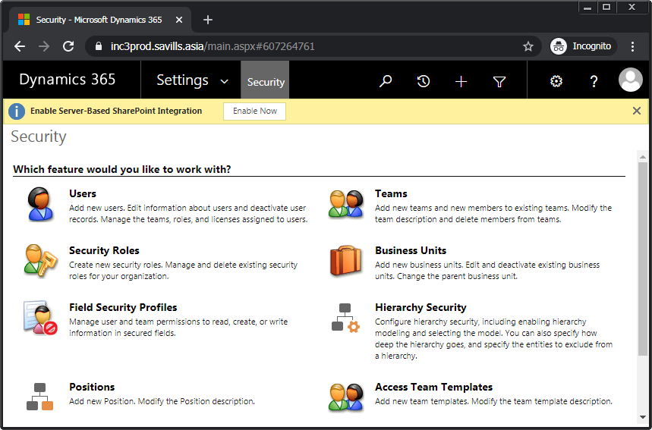
3. Select the “users” option from the main page to open the “enabled users” page.  
   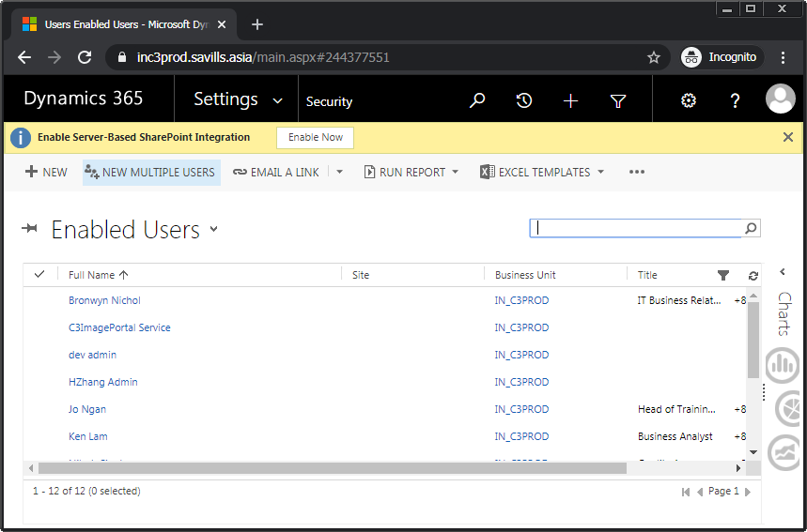
4. From here, invoke the “new” menu command. In the “new user” form, input into the “user name” field first. Use the format of “{domain name}\{user name}”. This has the advantage of allowing Dynamics CRM to pre-fill the other fields, such as those in the “user information” section. Use tabbing to accept the inputted value.
5. Select the “full name” field, which is initially shown as empty. The “first name” and “last name” sub-fields are now shown with their values already properly filled in, assuming the “user name” value entered earlier is a valid Active Directory account. Select “done” to accept.  
   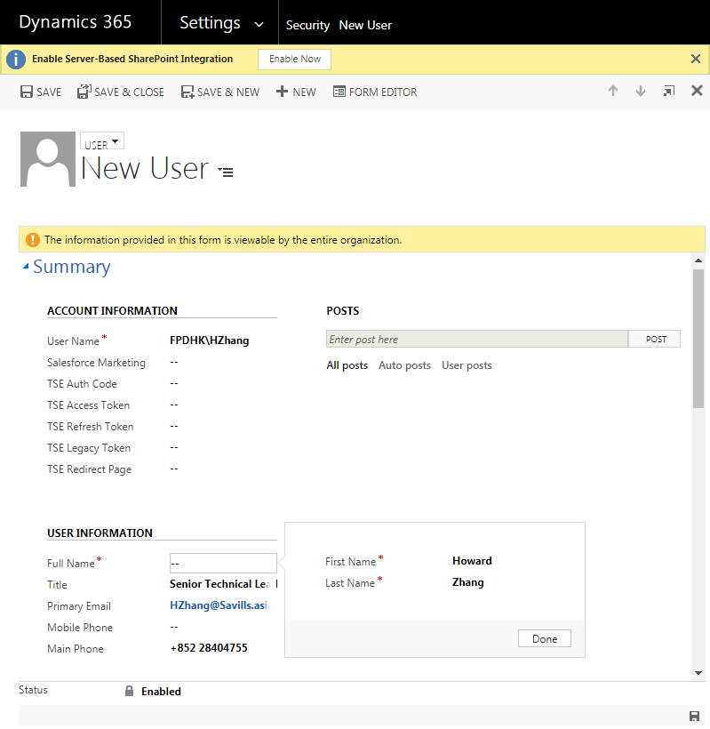
6. Invoke the “save” command for the new user entry.
7. Finally, complete the process by invoking the “manage roles” menu command for this user entry.
8. Select the appropriate role from the within the list shown in the “manage user roles” dialog. Select “ok” to complete the role assignment.   
   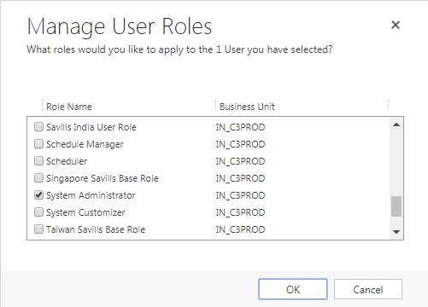  
   Note that the “system administrator” role should only be assigned to individuals performing technical setup or maintenance work.